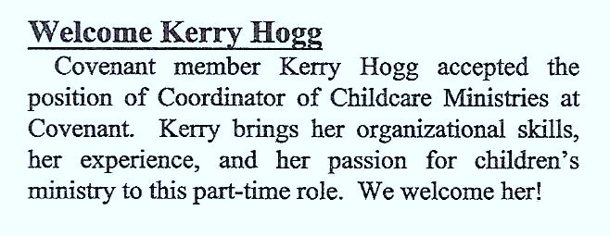
THE FOURTH 25 YEARS, PART 2, (2004-2010)
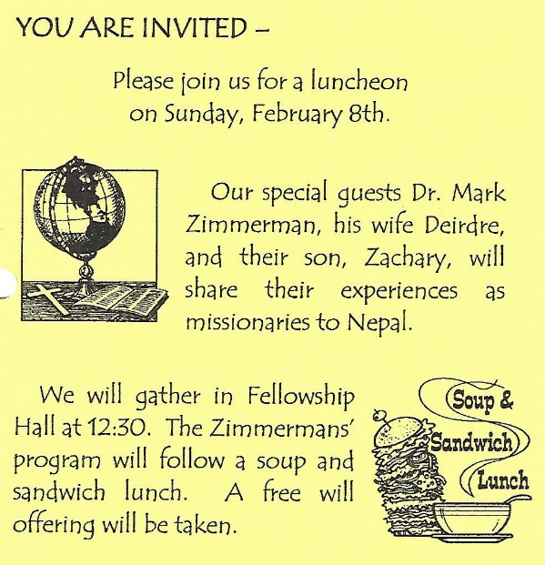
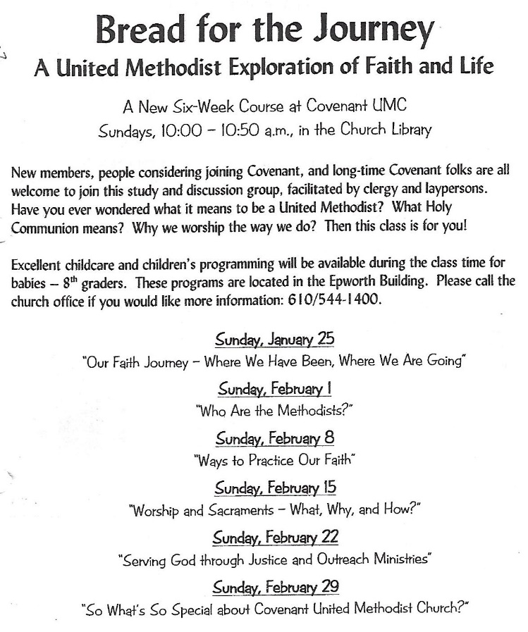

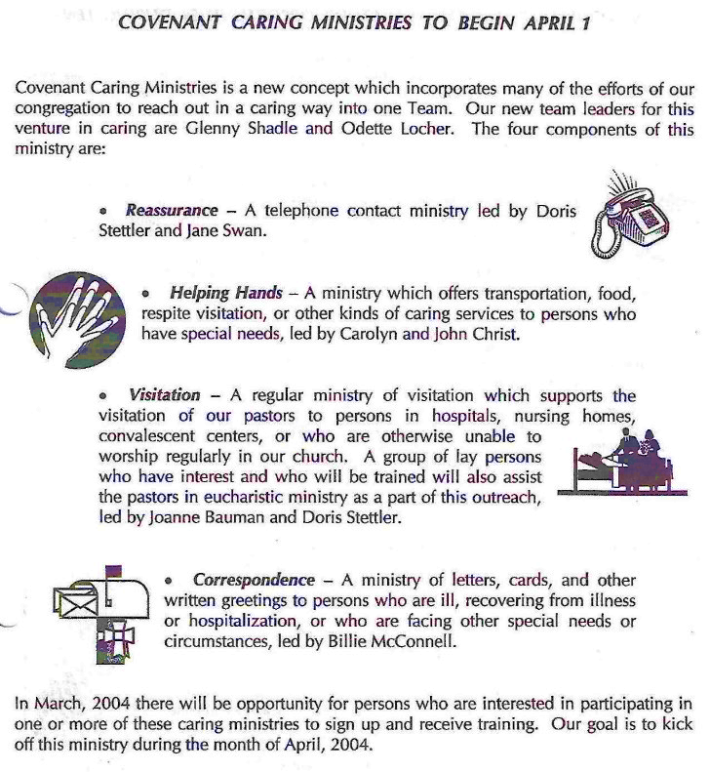
KATHY ATKINSON held a part-time position of Coordinator of Childcare Ministries at Covenant for the past few years. Because of increased hours at her regular employment, she decided to resign from her position at Covenant. Kathy continued to serve in other volunteer roles including as Sunday School Superintendent.
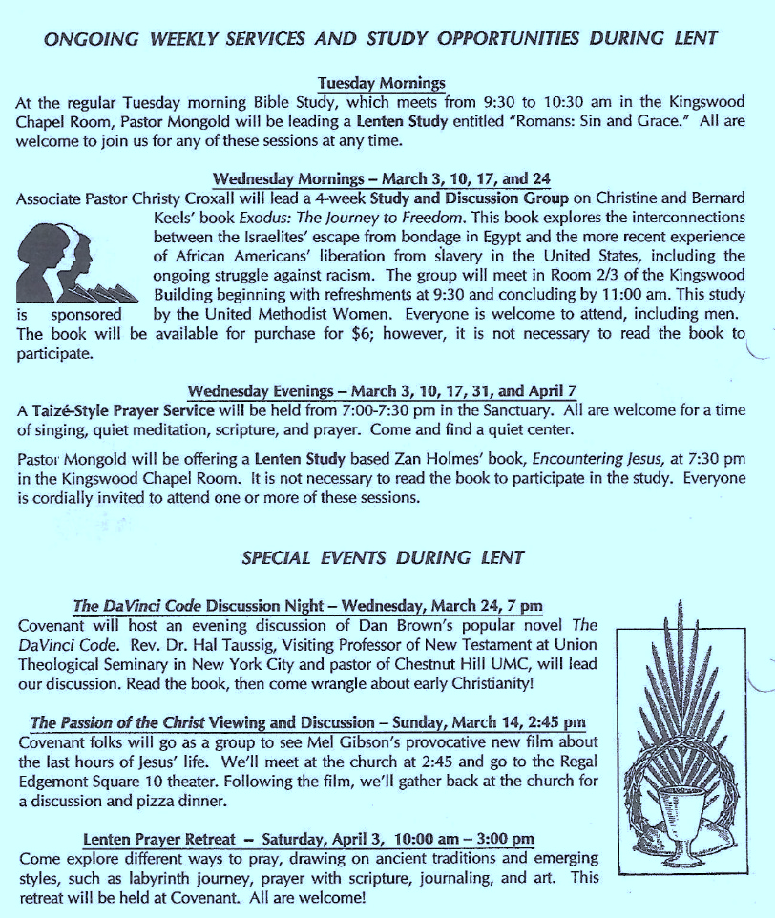
KID’S CHOICE: NEW MINISTRY FOR 1ST – 8TH GRADERS ON SUNDAY MORNINGS
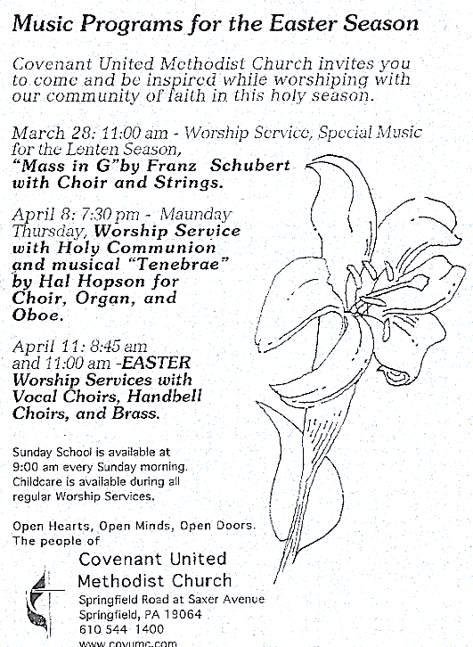
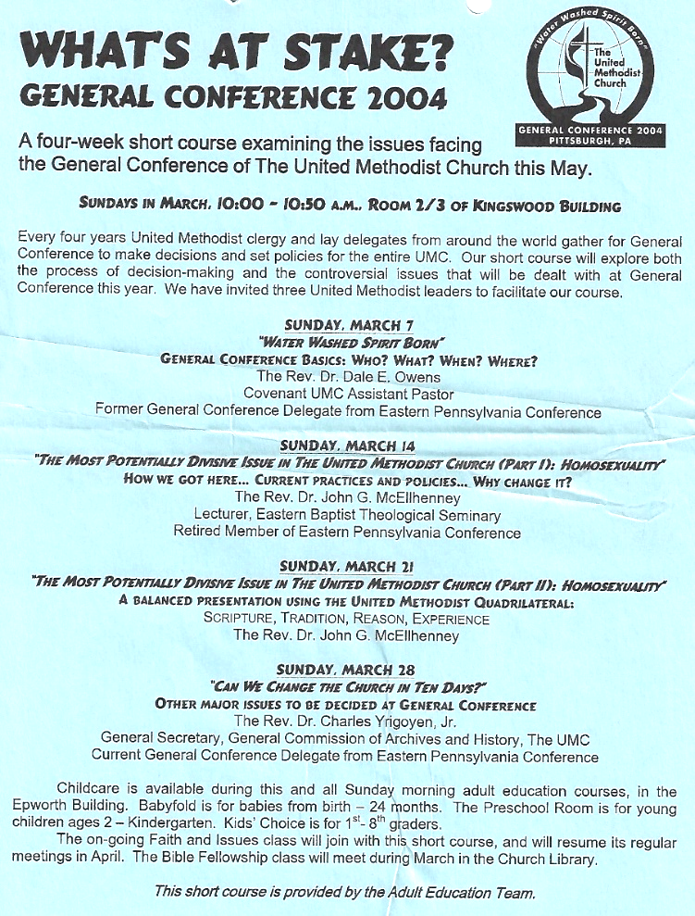
Kid’s Choice was a new ministry created for the needs of children during the 10-11 o’clock adult education hour on Sunday mornings. The program met in the People’s Room of Epworth. Each Sunday morning children in grades 1-8 gathered and chose from a number of activities including crafts, computer games, movies and stories. Dawn Hanrahan was the Co-ordinator for this ministry.

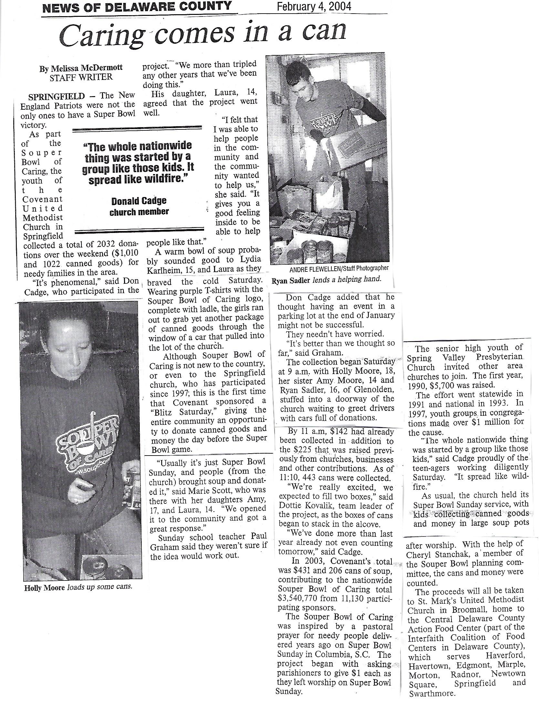

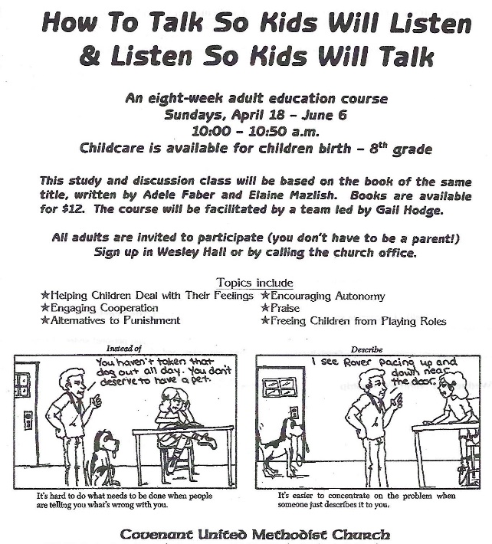
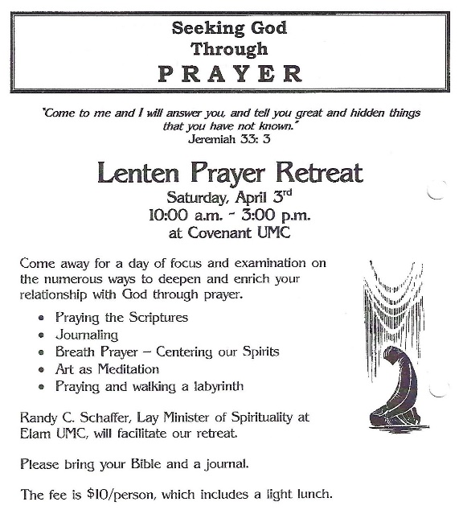
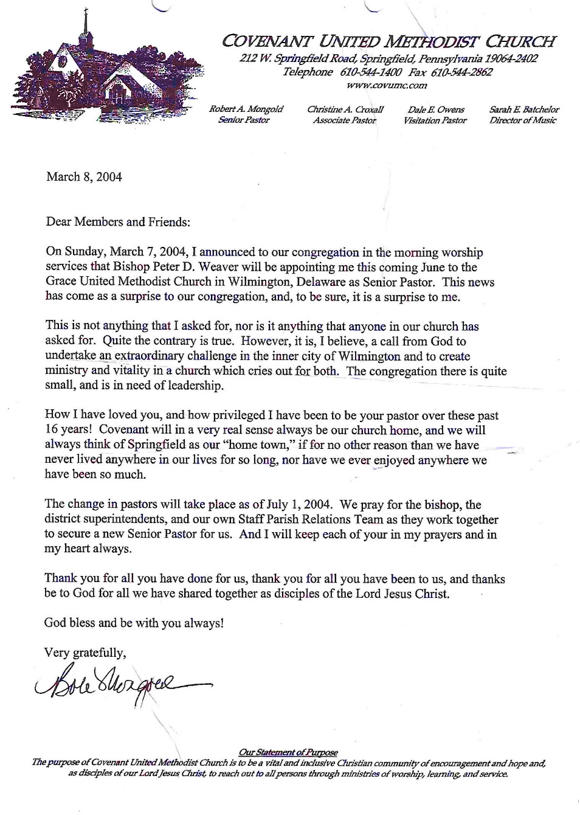
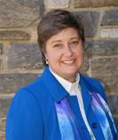
The Staff Parish Relations team announced that Bishop Weaver appointed REV. SHARON VANDEGRIFT (2004-2009) to the Senior Pastor position effective July 1, 2004. Rev. Vandegrift is a graduate of Albright College, Princeton Theological Seminary and the Institute for Life Coach Training. Her previous pastorate was Elam United Methodist Church where she served for six years.
Rev. Vandegrift
Also on July 1st, Rev. Christy Coxall was appointed to be the pastor of Asbury United Methodist Church in Norristown, PA

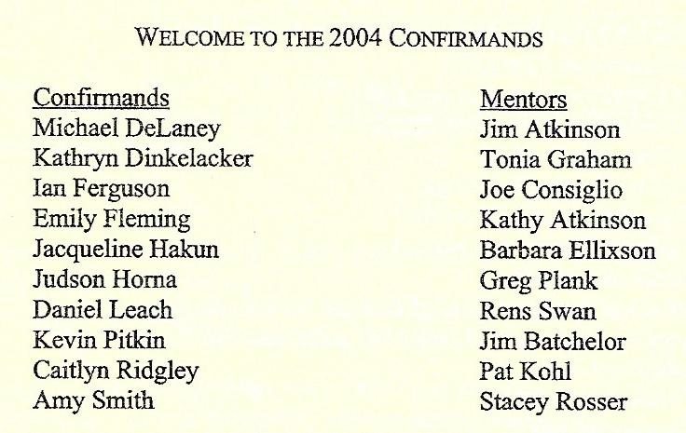
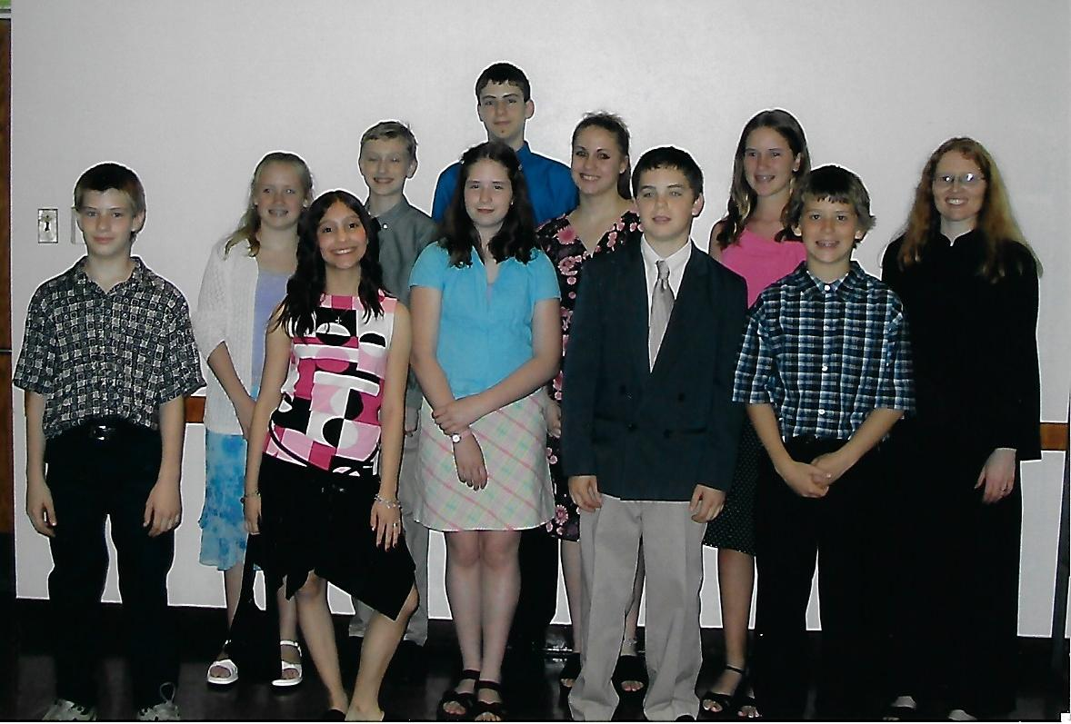
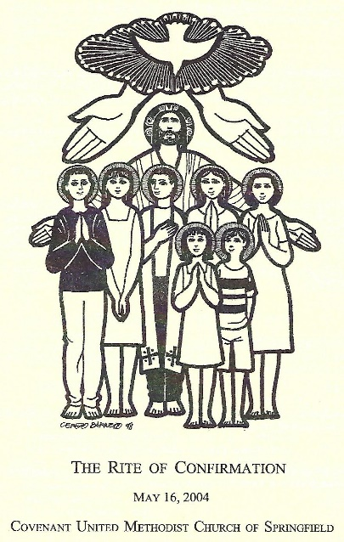
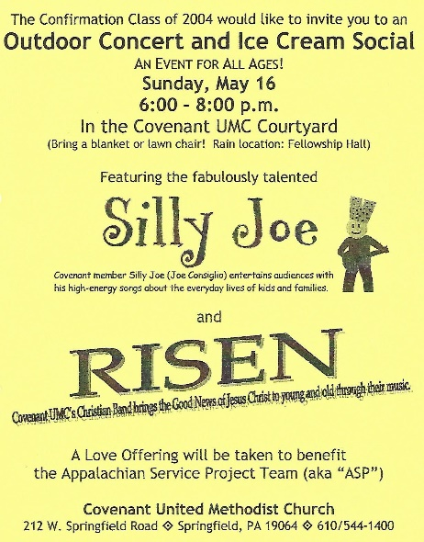LIFT (Literacy Is Fun Together) was a newly formed Covenant Team which worked with the Springfield School District on literacy, spending one hour a week one-on-one with a student helping him/her be better readers.
BLOOD DRIVE RESULTS: The Blood Drive held in April was a great success. Sixty-two people came to donate and they were able to obtain 52 units of blood. The Red Cross was hoping for 50 units. Covenant Red Cross team members were: Martha Murphy (Team Leader), Charlie Conklin, Kathy Williams, and Bill Clendenin.
At a congregation meeting in April members of Covenant gave approval to the Board of Trustees to secure a loan from the Conference Loan Board not to exceed $600,000 for a series of capital projects. The Board of Trustees was in the process of funding the two most critical capital projects: the replacement of the heating system and repairs to the gutters and soffits on the Kingswood Building. This Phase I Capital project was projected to cost $325,000.
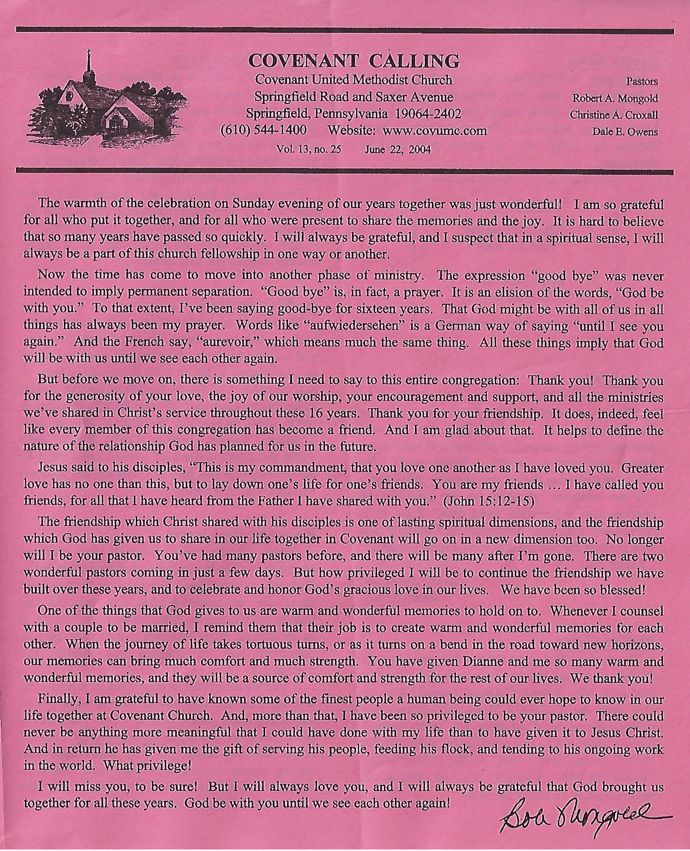
PARSONAGE: Unrelated to the capital projects, the Trustees requested approval from the Conference to sell the Williamson Lane parsonage. This decision was based on trends in pastoral housing arrangements over the long term and an analysis of the anticipated expenses versus possible rental income. The Hillcrest parsonage and the Saxer Avenue rental property were retained as buffers to the existing church properties and parking areas.
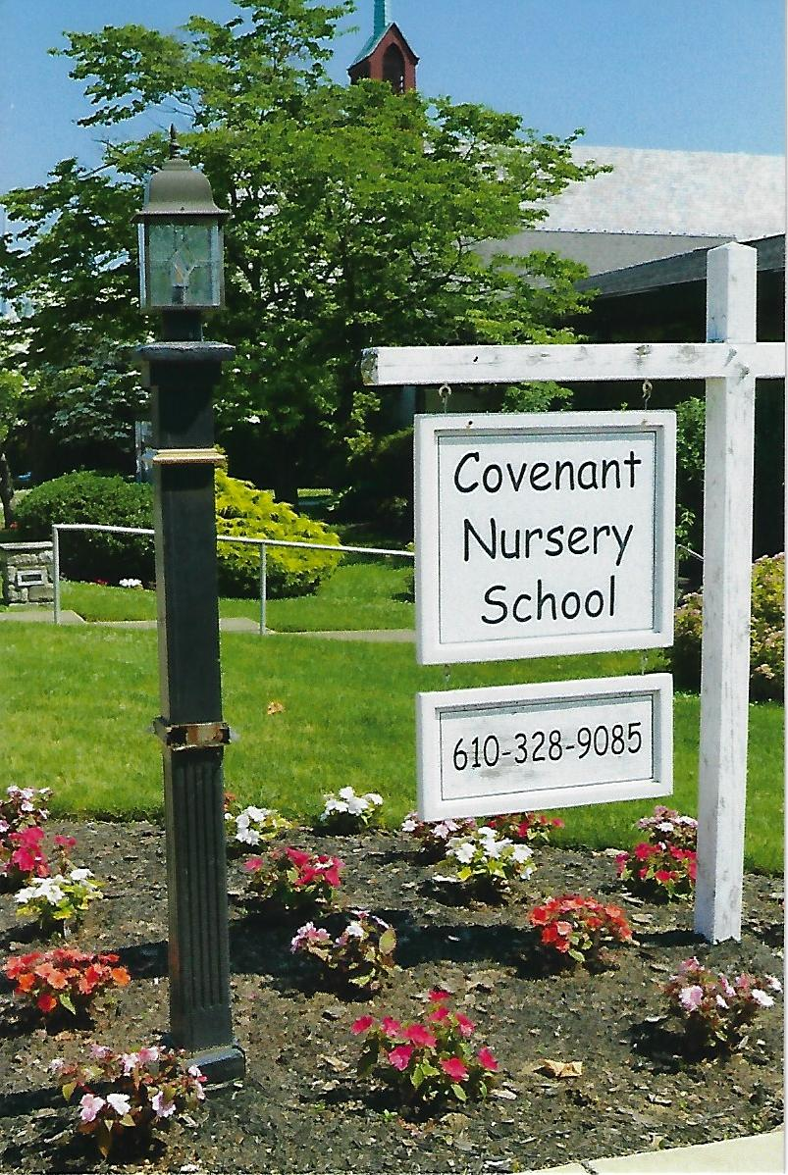
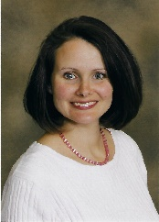
Bishop Weaver appointed WENDY HUDSON-JACOBY (2004-2006) to the position of Associate Pastor effective July 1, 2004. Wendy was a recent graduate of Wesley Theological Seminary in Washington, DC and came to Covenant from the Frankford Group Ministry in Philadelphia. She also spent time in India with the UMC Mission Intern Program.
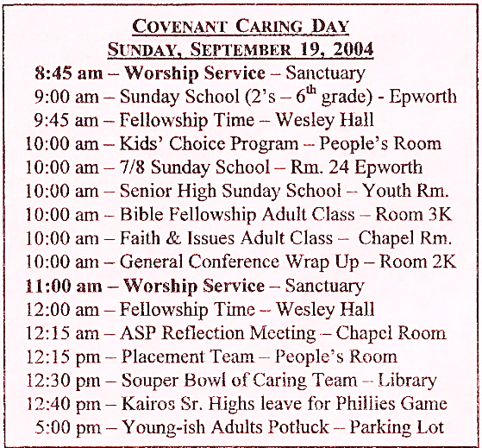
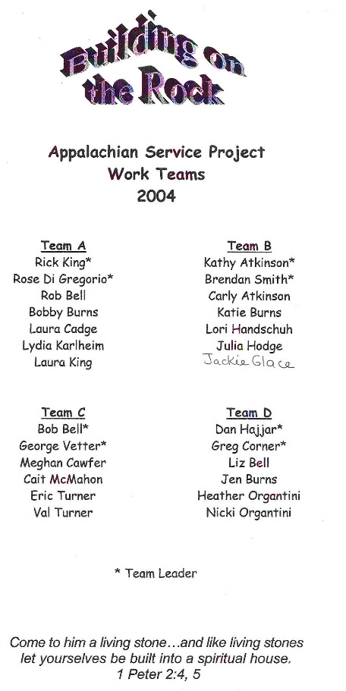
Each month the Sunday School chose a mission project in which to participate. In August it was decided to fill Flood Buckets with necessary cleaning supplies for Florida hurricane victims. The entire congregation was asked to participate. 

The lampposts along Saxer Ave. were made by Jack Woolfall and refurbished in 2022 by Alex Cole
Rev. Hudson-Jacoby

COVENANT CELEBRATED WORLD COMMUNION SUNDAY
Originally a Presbyterian observance, the Federal Council of Churches of Christ in America established World-wide Communion Sunday in 1940 as a global, interdenominational event. Prompted by the impact of World War II, the Methodist Church received an offering on this Sunday for the Fellowship of Suffering and Service. It aided the work of the Methodist Committee on Overseas Relief (now UMCOR), the Commission on Chaplains and the Commission on Camp Activities.

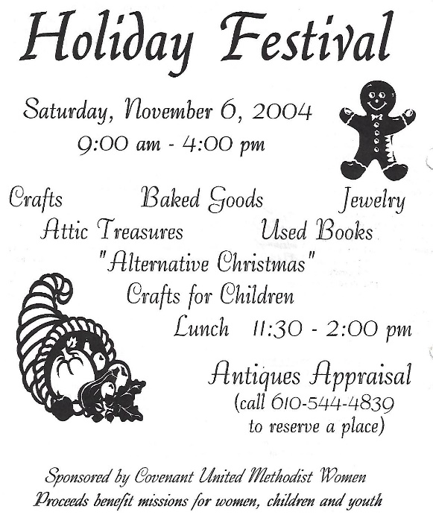
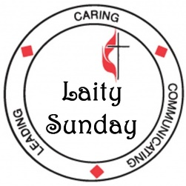
In the United Methodist Church, Laity Sunday is celebrated on the third Sunday of October. The ministry of laity in Covenant’s worship services was officiated by Don Cadge, Covenant’s Lay Leader. A number of church members participated in the services, and the Children, Junior and Chancel choirs joined together in singing a moving rendition of “He’s Got the Whole World in His Hands.” At the early service, those involved in teaching ministries at Covenant were dedicated, and at both services new members were received into the congregation. Worship was followed by the “Make Your Mark through Ministry” event, an opportunity for fellowship, refreshments and team sign-ups, sponsored by the Placement Team.
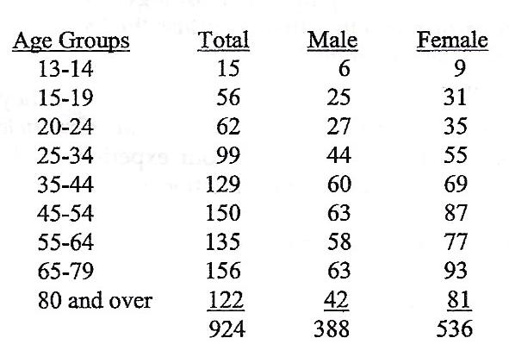
COVENANT MEMBER CHURCH PROFILE COVENANT CARING FOR GOD’S HOUSE
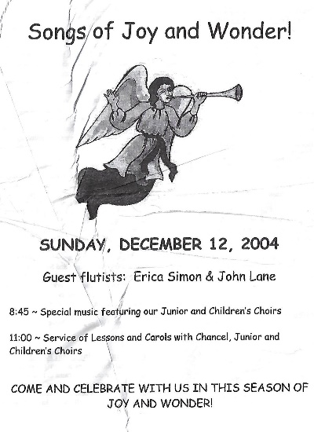
The formal solicitations for the Capital Campaign came to a conclusion on Sunday, November 7th. Responses were received from 187 families who pledged a total of $278,918 over the next three years. This allowed the Board of Trustees to undertake several capital projects of necessity: the installation of the new heating system and repairs to the gutters and soffits on Kingswood Building. Additionally, the outstanding loan for the construction of Wesley Hall was paid off.
On behalf of the parents at Covenant Church, Barb Ellixson, Patti Owens, Marion Garton, and Greg and Barb Plank were thanked for generously spending a part of their Christmas Eve in the Babyfold.
During Advent, a special course about Jesus was led by Dr. John McEllhenney of Eastern Baptist Seminary. The study was entitled “Who do People Say That I am?” and was held from 10 to 10:50 a.m. on Sundays in December.
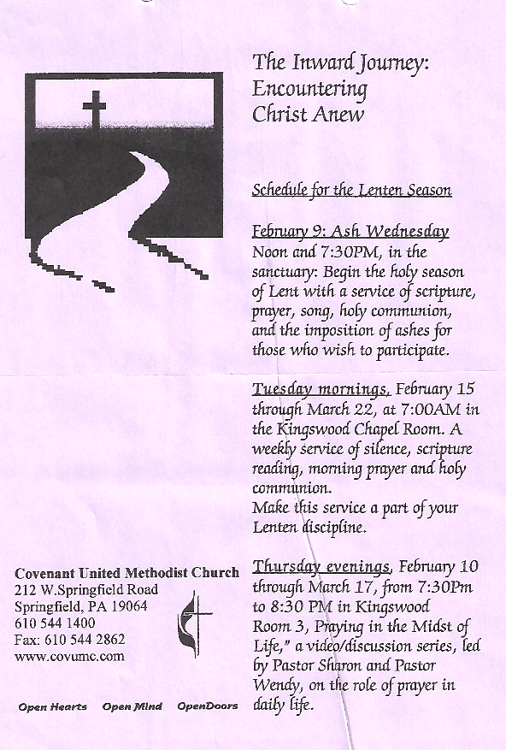
2005
After serving as part-time custodian for more than 20 years, ARNITTA RHYANES left Covenant at the end of February, and HARRY CARNEY, who had been a full-time custodian for the past six years transitioned to a new career in construction.
JOHN WESLEY
Sunday, January 23 through Sunday, February 6, the Adult Education group studied the book “John Wesley: Holiness of Heart and Life,” by Dr. Charles Yrigoyen, Jr.
WHITE TAG GIFTS GRATEFULLY RECEIVED
Covenant’s generosity helped men, women, families and children to have a wonderful Christmas. 290 gifts were distributed during the week before Christmas to the Life Center, the Eliz Shirley Center, Wesley House and St. Philips. Christmas gifts were also provided for families from the Frankford Group Ministries.
YOUTH SUNDAY
On Sunday, January 30th, Covenant’s youth presented both worship services:
8:45 a.m. Worship led by Confirmation Class and 7/8’s Sunday School
11:00 a.m. Worship led by Senior High Sunday School Class and RISEN

SOUPER BOWL OF CARING
MR. QUIMPER RETURNS
Mr. Quimper, Covenant’s resident wise, elder puppet, came for a special visit to the kindergarten and first-grade Sunday school class on January 23rd. He and his friends talked to the kids about being good friends, how much God loves them and how great Bibles are. All first graders received their own Bibles.
The total collection on Blitz Saturday and Super Bowl Sunday for all the participating churches (First Presbyterian, St. Matthew’s Lutheran, Life Christian Fellowship, Princeton Presbyterian, St. Francis of Assisi, The Blue Church and Covenant) was 4,610 cans and $5,697 in cash. This quadrupled the collection from last year.

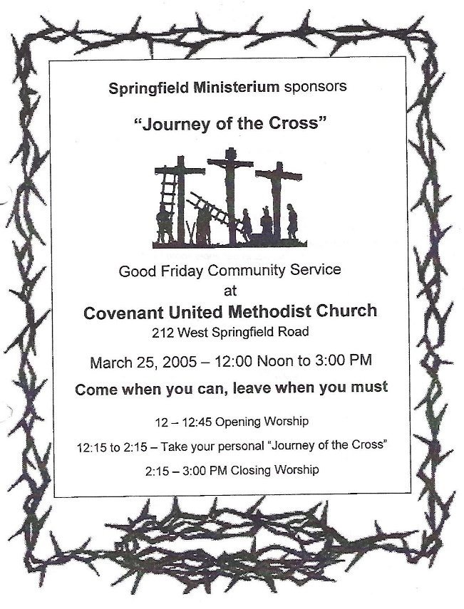
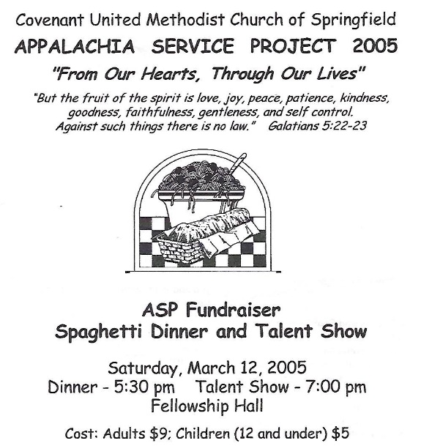
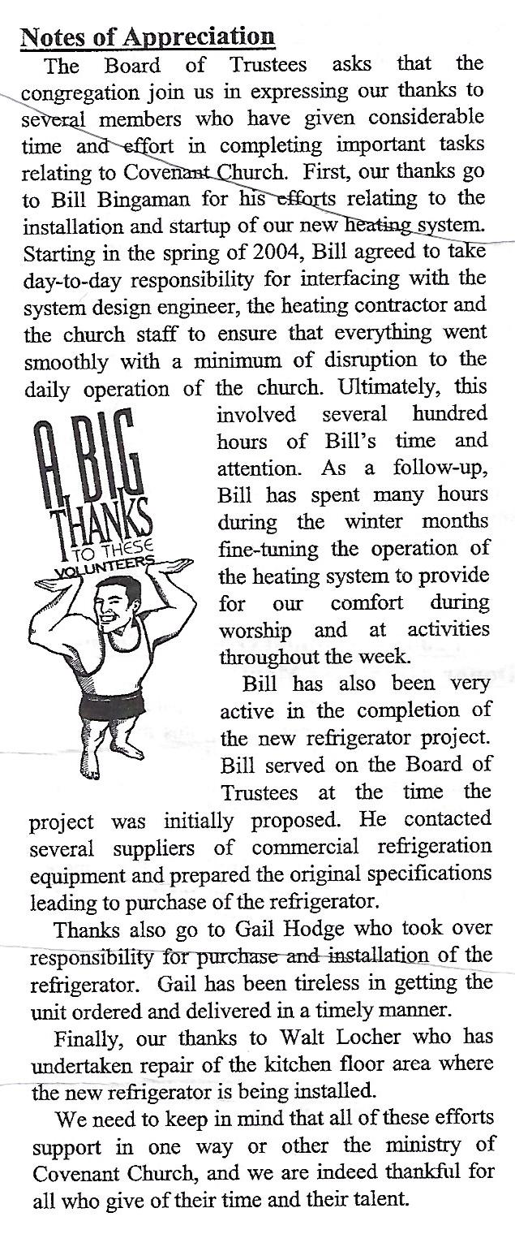
CONFIRMED ON MAY 22ND
COVENANT NURSERY SCHOOL celebrated their annual Arts Festival on Tuesday evening, April 19th. Their artwork was displayed in hallways and rooms in the Epworth Building.
Alyssa Colston Hannah Karlheim
Matt Danelutti Hayden Karlheim
Leah DeBenedictis Sarah Mehalick
Janel Folkomer Caitlin Mulkeen
Kristina Genzel Christopher Roberts
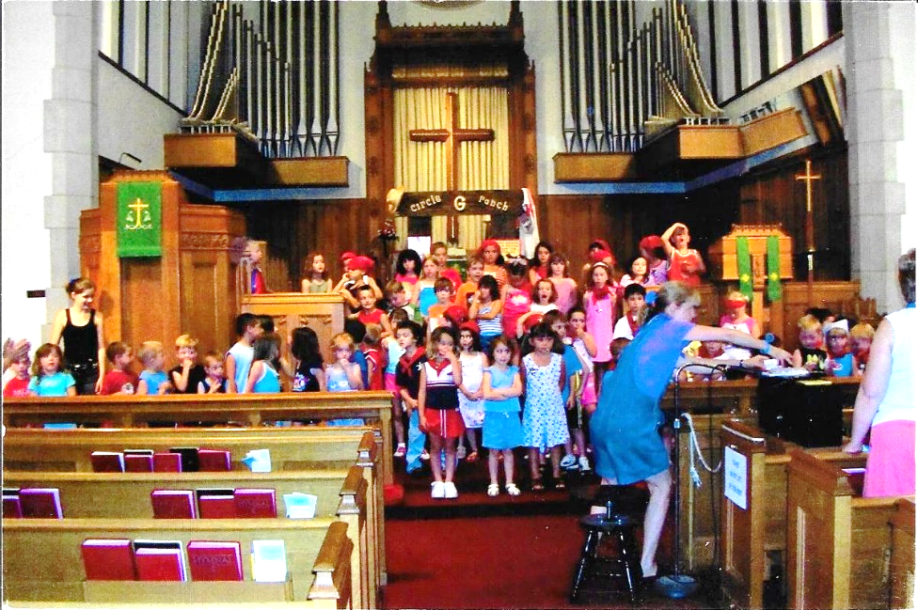
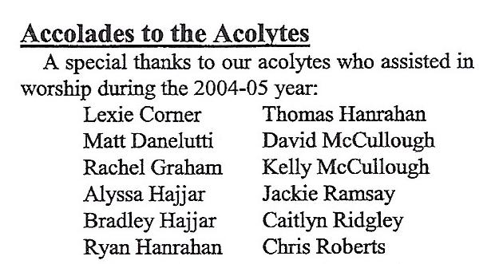
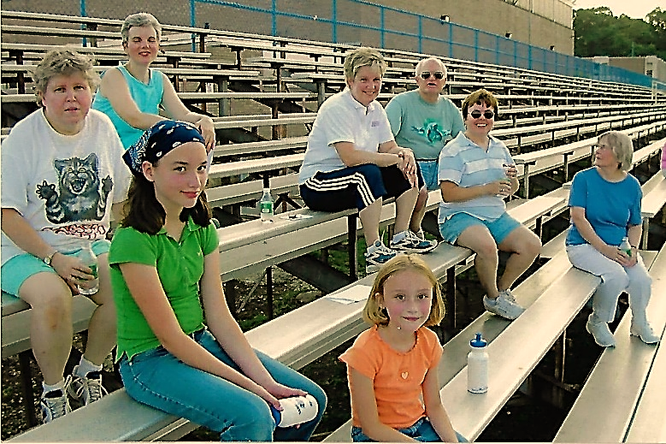
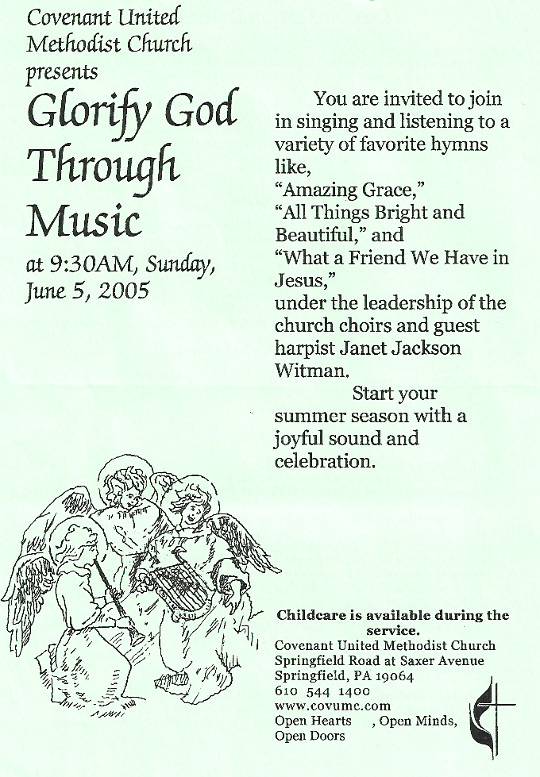
FELLOWSHIP PICNIC WITH HANCOCK UMC
CHILDREN’S CHURCH
Beginning Sunday, June 12 and continuing for 13 weeks, a Children’s Church summer program for kids ages 3-rising 5th graders were invited to stay in worship through the children’s moment and then were led to Fellowship Hall for a time of worship kid-style.
Currents Walking Group
In spite of the heat of the day, 72 adults and 14 children enjoyed a fellowship picnic on Sunday, July 24th at C.C. Hancock UMC.
VACATION BIBLE SCHOOL PROGRAM: Preschoolers through Grade 5 were invited to join the “Circle G Ranch” where God was at the center and love never ends. Through the week, participants experienced a deeper relationship with God while enjoying crafts and games, listening to action-filled Bible stories, sampling tasty snacks and singing unforgettable songs. A Family Roundup was held at the end of the week.

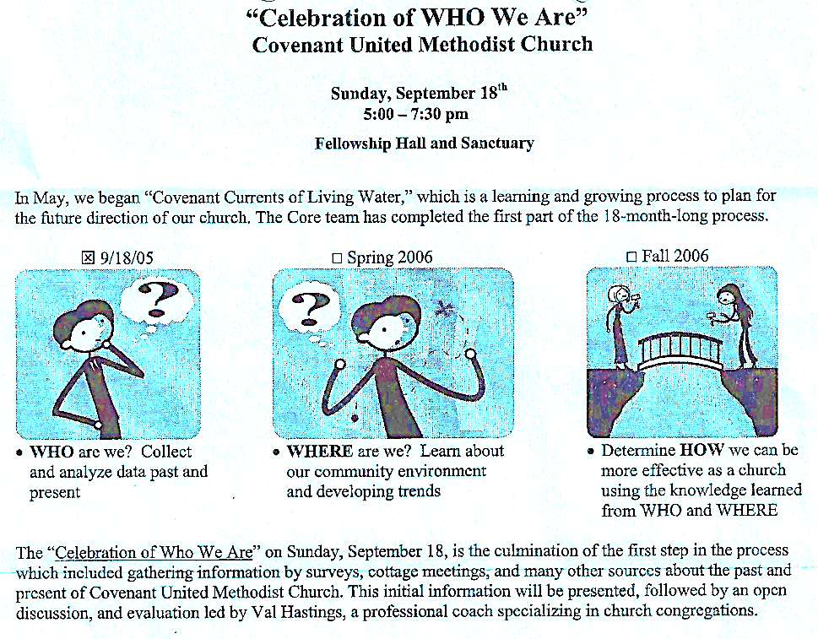
COVENANT WELCOMES NEW YOUTH MINISTRY COORDINATOR
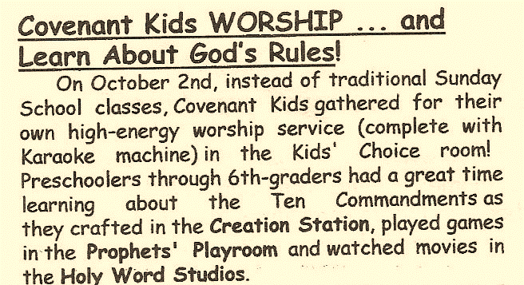
The Staff Parish Relations Team announced that Shellina Mtika was hired as Youth Ministry Coordinator effective October 15th. She oversaw the youth group activities for Kairos 7/8’s and the Senior High Youth Group. Shellie was a 2005 graduate of Eastern University with a degree in Youth Ministry. Thanks were given to the search taskforce that worked many months to create a job description and interview candidates: Jim Atkinson, Ruthanne Ferguson, Lori Ridgley, Sherman Roberts, Laura Scott, and Pam Townsend.
SENIOR HIGH ACTIVITIES FOR OCTOBER 16
On Sunday Covenant’s Senior Highs participated in the following activities:
● Led the 8:45 a.m. worship service for “Make Your Mark” Laity Sunday
● Participated in the Philadelphia AIDS Walk
● Participated in the Crop Walk in Swarthmore
● Attended the Super Bowl of Caring Brainstorming Session at First Presbyterian


THANKS FOR A JOB WELL DONE……….A special thanks was given to the Wednesday Night Fellowship Team who served Covenant faithfully for many years by providing a mid-week family fellowship opportunity. With attendance down and costs rising, it was decided to end the Wednesday Night Fellowship program.
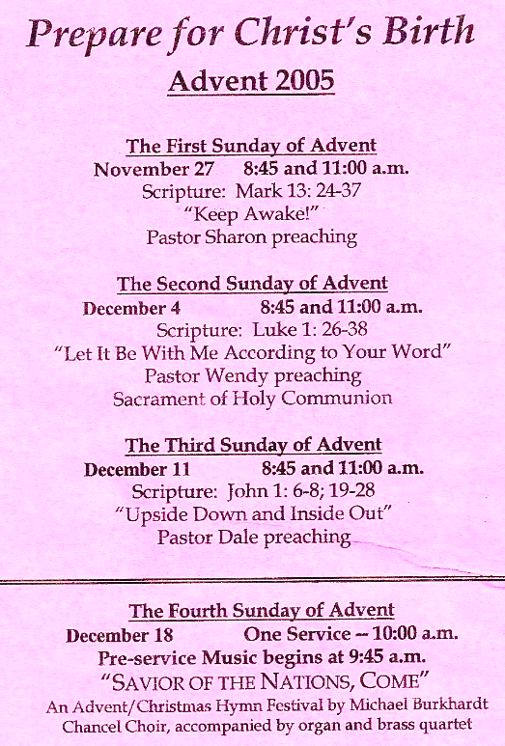
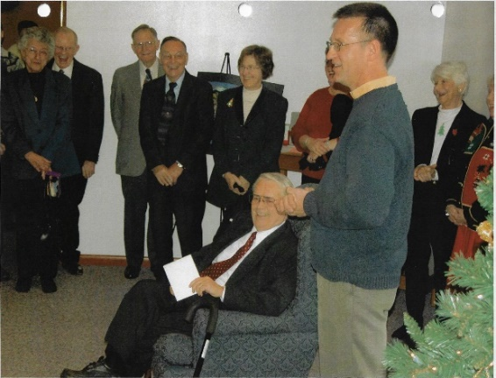
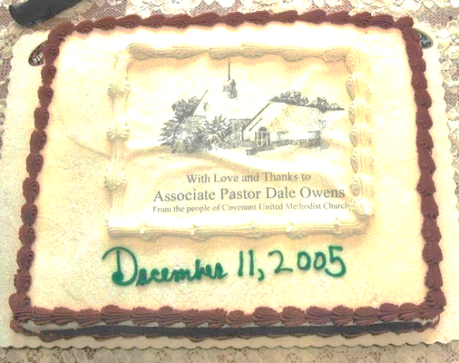
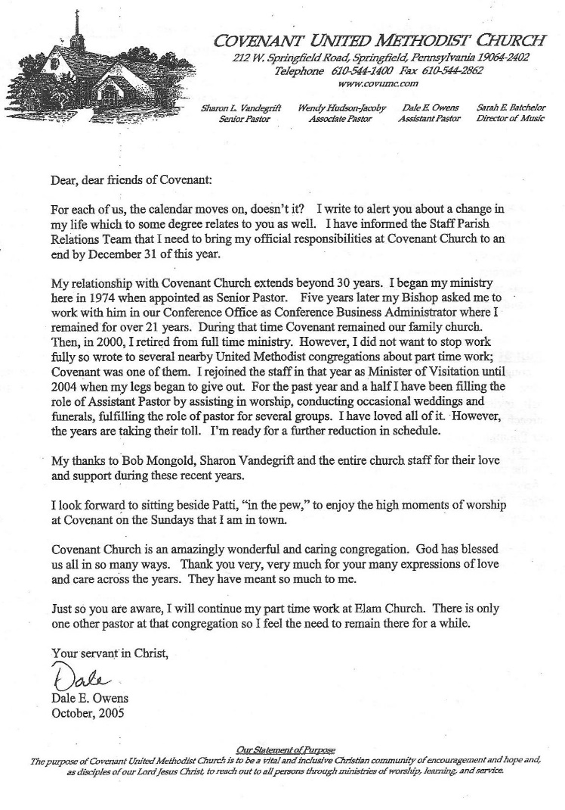
A RECEPTION WAS HELD ON DECEMBER 11TH FOR REV. OWENS
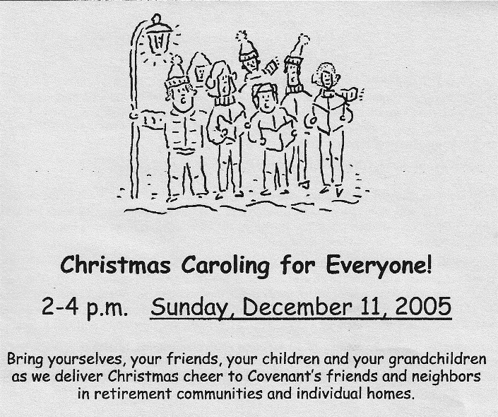

2006
2006 MARKS 50TH ANNIVERSARY
2006 marked the 50th Anniversary of women in the Methodist tradition being granted full rights, a decision made by the 1956 General Conference. In the Annual Conferences held following that General Conference, 26 women in the United States and one woman in Hungary were received into conference membership on probation.
CHURCH LIBRARY MAKE-OVER
The Library was renovated with fresh paint, new carpet and furniture which was made possible by a generous bequest from the estate of Martha Smith who was a dedicated teacher committed to life-long learning.
MEN’S BREAKFAST
The United Methodist Men met for breakfast on Saturday, January 14th to hear Dr. Eugene Richardson, a member of the Tuskegee Airmen, speak about the Airmen and their role in WWII.
CHILD CARE CHANGES
A new Childcare Coordinator was announced in January. Carolyn Hathaway graciously agreed to oversee the Babyfold and Kids’ Choice. Thanks were expressed to Kerry Hogg, Childcare Ministry Coordinator and Dawn Hanrahan, Kid’s Choice Coordinator, for their caring and dedicated leadership of these programs over the past years.
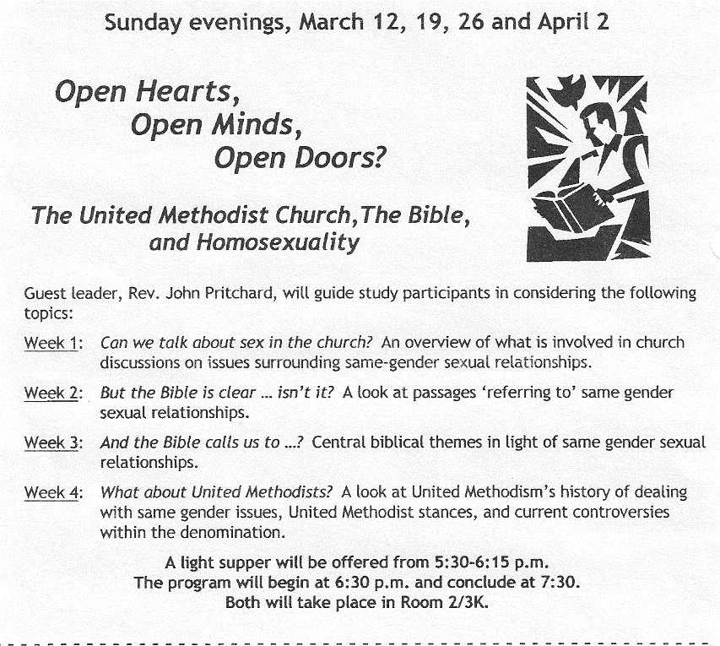
SOUPER BOWL OF CARING HAD A HUGE VICTORY!!
The total collection for Blitz Saturday from the community was spectacular. The total of cans/food so far was over 5,000 items. That evening 125 people joined together for the second annual Soup Supper which was hosted by St. Matthew’s Lutheran Church. During that event, additional cash donations amounted to $692. Both the food and money were given to the Interfaith Coalition of Food Centers. The evening was topped off with Covenant’s band RISEN donating their time and talents. The following day, collections were made at Covenant where 478 cans/food and $877 cash were added to the community-wide success.
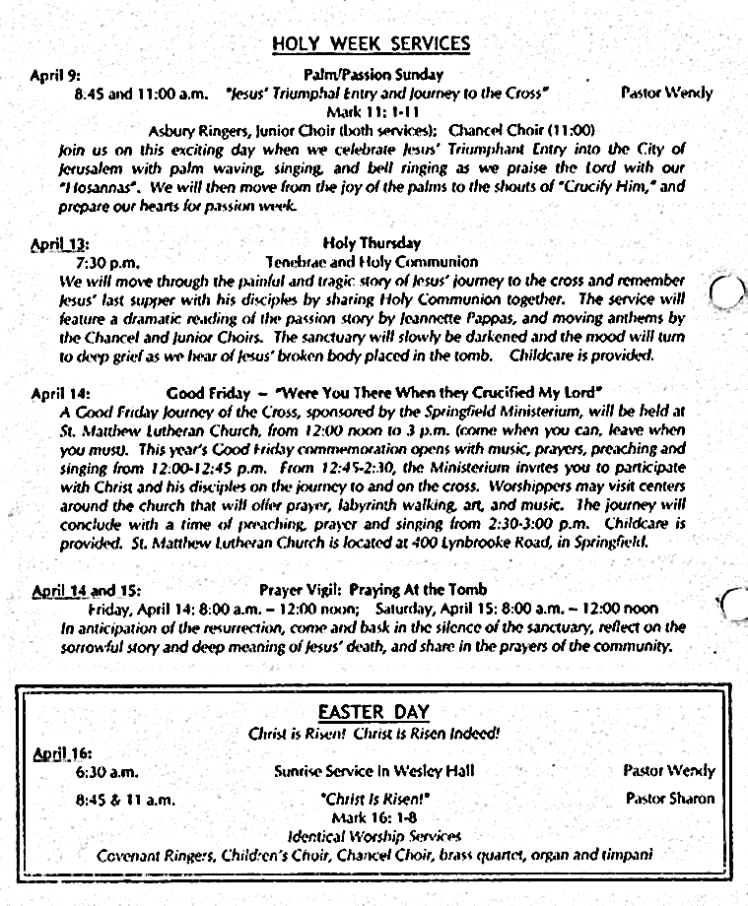
GUEST PREACHER SCHEUDLED FOR FEBRUARY 26TH
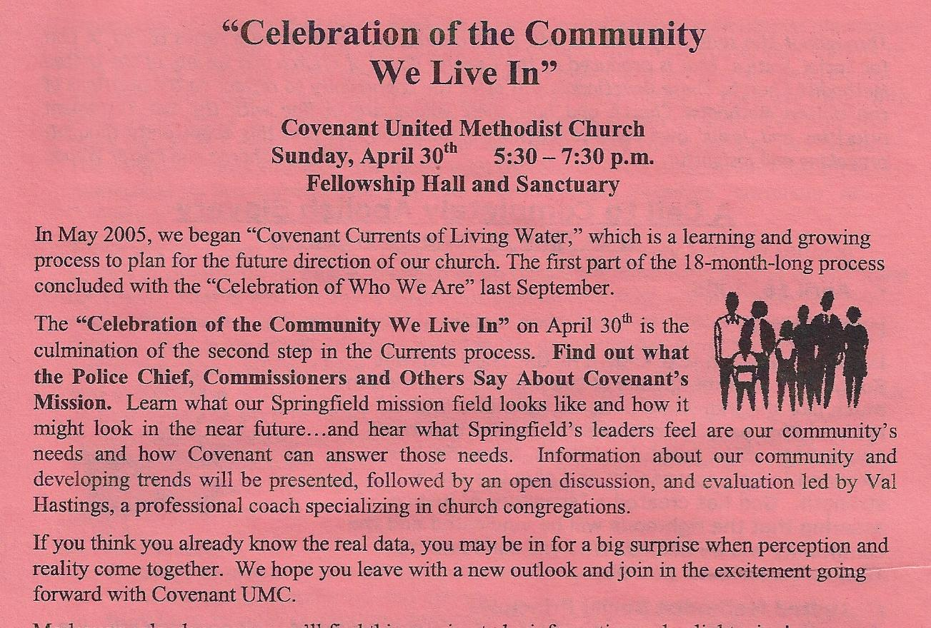
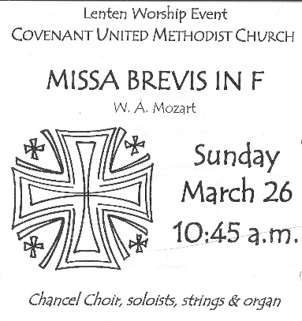
The Rev. George I. Bustard served as the guest preacher for both services, preaching on the topic “Looking for the Lord.” Rev. Bustard was the Director of the Center for Pastoral Counseling at Springfield which is housed at Covenant. Covenant has been a long-time supporter of the Center and Pastor Sharon served on the Board of Directors. In addition to being a trained Pastoral Counselor, Rev. Bustard is an ordained pastor in the Presbyterian Church.
SUNDAY MORNING SHORT COURSE
Scott Neumann led a study of the book, “Reaching for the Invisible God,” by Philip Yancey during the educational hour at 10 a.m.

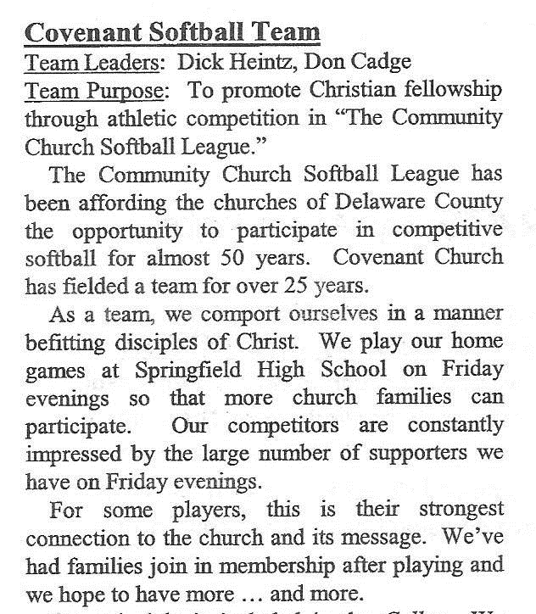
KUDOS
A special thanks was given for the gifts of time and talent by the grounds crew led by Dave Liscom. The loveliness of the church grounds made Covenant a welcoming and beautiful place for many to experience on Easter Day. Participants were:
Brian Bingaman Mike Hudson-Jacoby
Barb Bunting Wendy Hudson-Jacoby
Bud Dalrymple Dawn Liscom
Edna Graham Dave Liscom
Paul Graham Mike Ranck
Carolyn Hathaway Chuck Smith
Bob Hick Michelle Smith
Brian Hogg Nancy Walls

Mike Ranck, Chairperson of the Staff-Parish Relations Committee announced in May that Pastor Wendy Hudson-Jacoby would be leaving Covenant as she continues her Christian journey and assumes a new pastorate in West Grove, Pennsylvania.
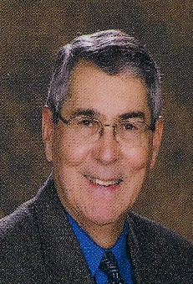
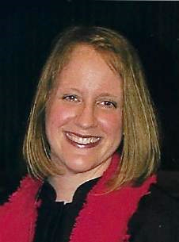
Also in May, it was announced that REV. AMY EMMETT-RARDIN (2006-2010) would become the new Pastor of Ministries with Children, Youth and their Families. Pastor Amy served as pastor of Parkside United Methodist Church from 2002-2005 and most recently as pastor of Spring City United Methodist Church. She holds a Bachelor of Arts degree in English Literature and a Certificate of Secondary Education from Otterbein College in Westerville, Ohio as well as a Master of Divinity degree from Candler School of Theology at Emory University. In her new capacity at Covenant, she served as a resource to teams that relate specifically to the areas of Children, Youth and their families while serving as supervisor of Carolyn Hathaway, Childcare Coordinator, and Shellie Mtika, Youth Ministry Coordinator.
Rev. Emmett-Rardin
In June REV. LAWRENCE R. BERGSTRESSER (2006-2012) came to Covenant as the new Pastor of Visitation. Pastor Larry is an ordained elder in the United Methodist Church and served throughout the Eastern PA Conference for 35 years. He holds a Bachelor of Arts degree from Albright College, a Divinity degree from Pittsburgh Theological Seminary, and a Clinical Program Certificate from the Pennsylvania Foundation of Pastoral Counseling. He has a special interest in mission work and just recently returned from leading a Katrina Recovery Mission group in Mississippi.
Rev. Bergstresser
LIFE CENTER SUNDAY: On Sunday, June 25th, a celebration of Covenant’s ongoing ministry with The Life Center in Upper Darby was held with the Rev. Jim Shelton, Director of The Life Center offering the morning’s sermon. Sue Clendenin, Covenant’s Life Center Team Leader, also participated in the service. In addition to Covenant’s every other month involvement, this year’s Vacation Bible School focused its mission efforts on the work of this ministry by collecting personal care items. During the week of VBS, Rev. Shelton visited the children and offered a message regarding the importance of this service ministry.
FOURTH OF JULY AT COVENANT
Covenant served as a hospitality center during the Springfield 4th of July Parade. Cold lemonade was offered and Wesley Hall was open to provide a place for parade goers to pause for a moment in an air-conditioned space.

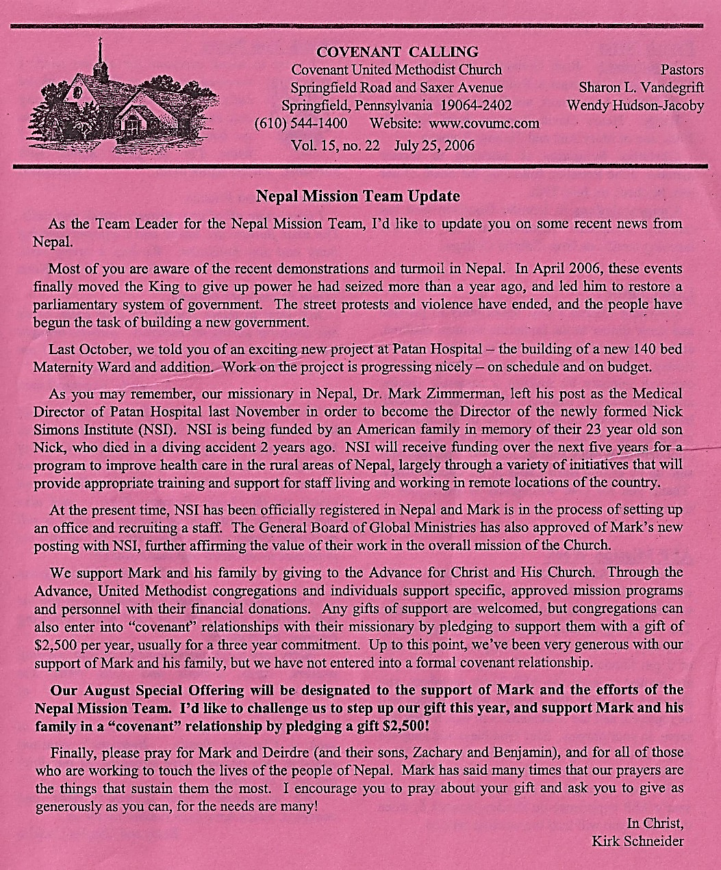
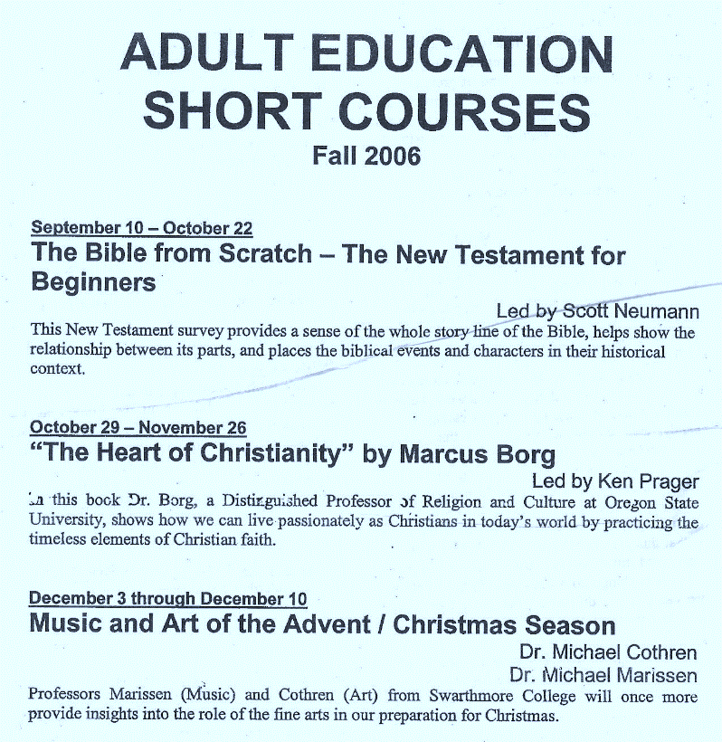
NEW COMMUNION TABLE DEDICATED
HARLEE MANOR SERVICES
The Harlee Manor Team conducted a worship service with the residents on Sunday, November 5th. Elizabeth Hearn delivered the message, Ryan Hanrahan played the saxophone, Lee Windle provided piano accompaniment for the hymns, Eleanor Roberts read the scripture lessons, and Kathy Atkinson led the prayers.
A new communion table was dedicated on December 3rd in honor of Ralph Miller’s 90th birthday. The gift was given by his family.
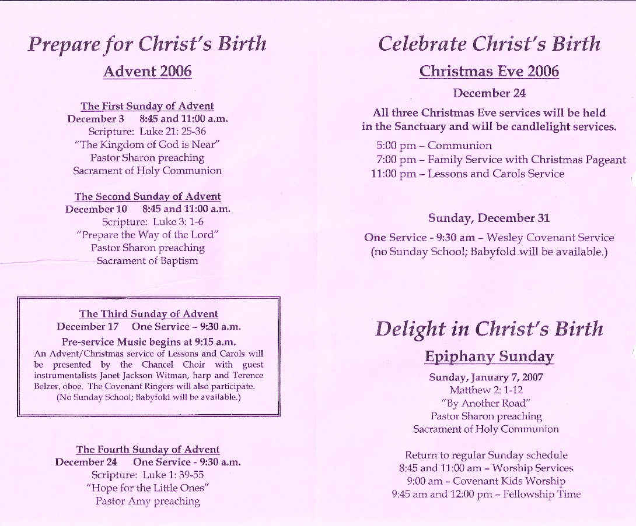
The HARVEST HOME TEAM thanked everyone at Covenant for the tremendous amount of food collected. Each agency (Neighborhood Services, Loaves & Fishes, Domestic Abuse Center and CityTeam Ministries) received five large boxes of food along with a check in the amount of $59 to buy turkeys and whatever else they needed.
A special thanks also from the ADVENT CELEBRATION TEAM for the offering totaling $325 taken at the event. This was given to support the community Christmas dinner sponsored by the Frankford Group Ministry in Philadelphia.

2007
NEW CHIDREN’S COORINDATOR ANNOUNCED
Covenant welcomed a new leader as part of the church’s ministry to families with young children. Beginning in January, Barb Smith accepted the position of Child Care Coordinator. As Barb was welcomed, thanks were given to Carolyn Hathaway for the time and energy she gave to this position.
PRIORITY: YOUTH
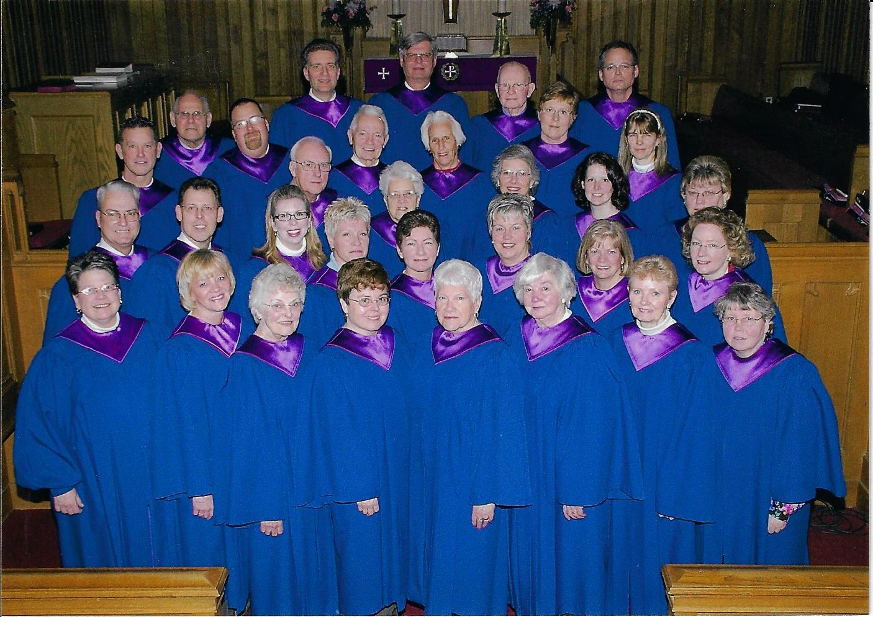
On Sunday, February 11th, the Covenant Youth Group led both services of worship under the direction of Shellie Mtkia (Youth Coordinator), Pastor Amy and other adult volunteers. A special aspect of the service was a reunion of the Junior Choir…former members who were now in grades 5-12. Covenant’s band RISEN offered the prelude music and an anthem.
Chancel Choir 2007
The Lenten special music was presented at both the 8:45 a.m. and 11:00 a.m. services. The Chancel Choir presented K. Lee Scott’s Requiem with accompaniment by viola, cello, flute, 2 horns, harp, timpani and organ.
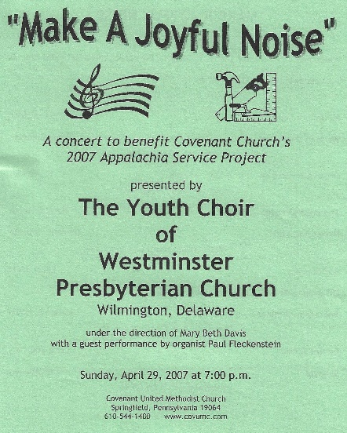
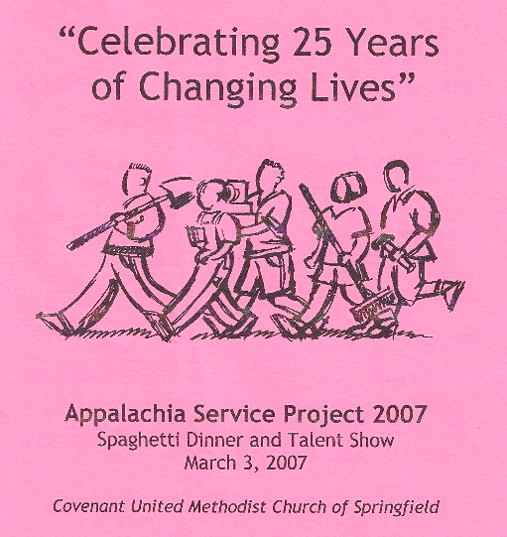
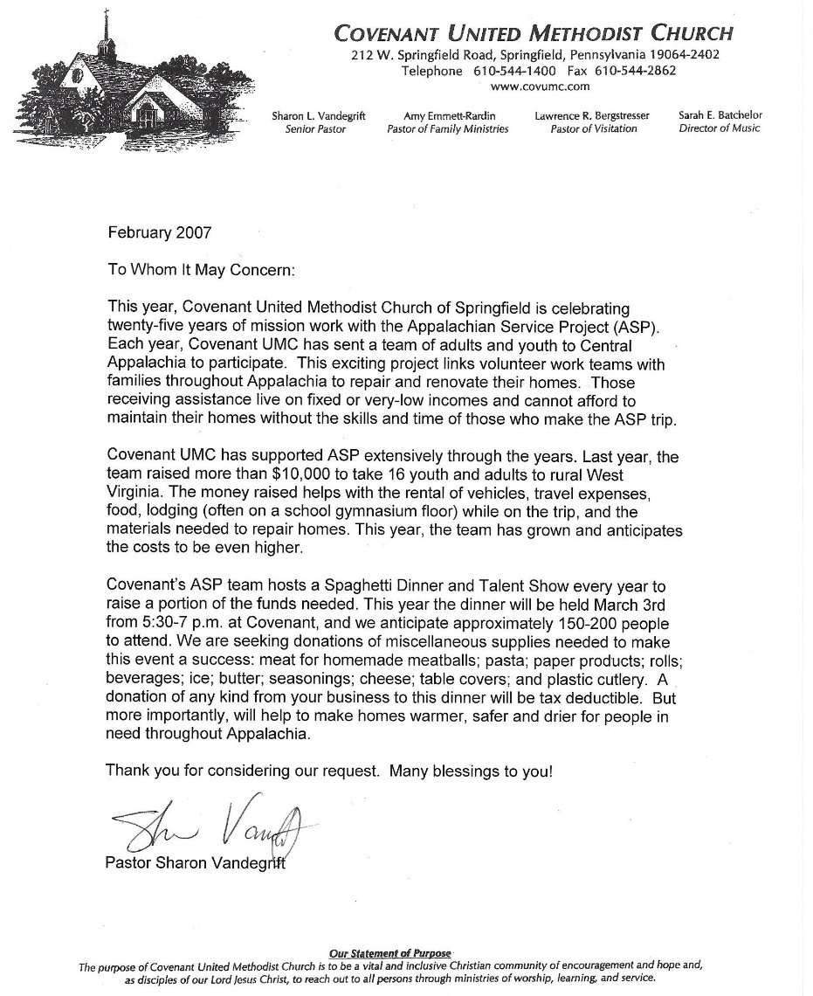
ASP 25TH ANNIVERSARY YEAR

COVENANT 2007 ASP PARTICIPANTS
Kathy Atkinson | Marcia Hickey | Caitlyn Ridgley
Chrissy Bannon | Judson Horna | Lori Ridgley
Laura Cadge | Hannah Karlheim | Alex Rothera
Greg Corner | Hayden Karlheim | Laura Scott
Abby Denk | Lydia Karlheim | Chris Serrano
Janel Folkomer | Michael Karlheim | George Vetter
Jackie Glace | Michael Krezdorn | Dan Wallin
Nick Gunther | Andrea Ridgley | Peter Weiss
Jacqui Hickey

Covenant Ringers (top)
Asbury Ringers (bottom)
KATRINA RECOVERY MISSION

Michael Karlheim, Dave Liscom, and Pastor Larry represented Covenant as they traveled to Mississippi to help in the recovery of damage from hurricane Katrina.
UNITED METHODIST WOMEN LENTEN STUDY
“Ordinary Women Doing Extraordinary Things”
This study looked at the women involved in Jesus’ ministry during Biblical times and today, and celebrated the way ordinary women have done extraordinary things to make a difference in the Church and world. Kelly Martin, former Director of communications of the Women’s Division of the Board of Global Ministries of UMC was the guest leader.
YOUTH ORCHESTRA
Sunday, June 3rd
A youth orchestra comprised of Covenant members played at the morning worship service. Instrumentalists were:
Laura Cadge Violin
Natasha Hakun Trumpet
Hannah Karlheim Flute
Hayden Karlheim Viola
Lydia Karlheim Oboe
Caitlyn Ridgley Horn
Chris Roberts Cello
Sandra Stewart Clarinet

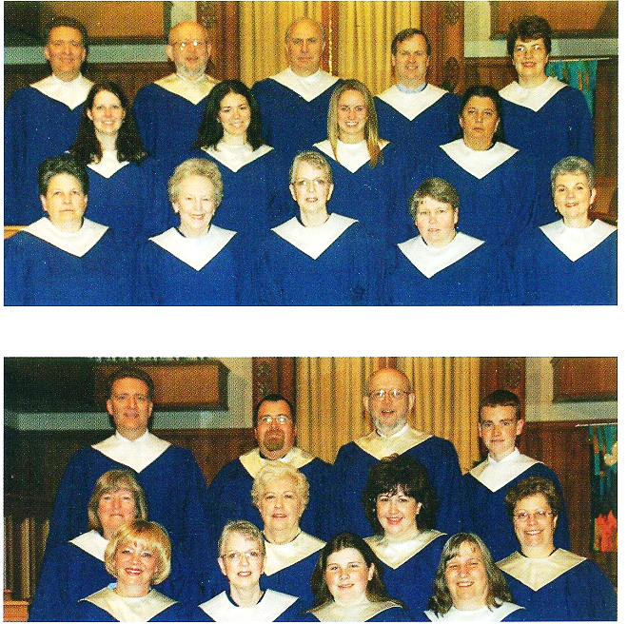
YOUTH MINISTRY COORDINATOR TRANSITION
Covenant’s Youth Ministry Coordinator, Shellie Mtika moved on from Covenant in June to accept a full-time position at another church. Covenant’s own Lori Ridgley will be working as Covenant’s Youth Ministry Coordinator beginning in the fall.
C.S. LEWIS: “ THE SCREWTAPE LETTERS”
“My dear wormwood….’ So begins this product of C. S. Lewis’s wickedly funny imagination, a correspondence between two devils, Screwtape and his young nephew, Wormwood. As the senior fiend advises his young apprentice in leading humanity astray, Lewis delves into questions about good and evil temptations, repentance and grace, offering knowledge and guidance to all who are trying to live good Christian lives.” A 6-week adult study of this book was led by Jim and Betty Batchelor.

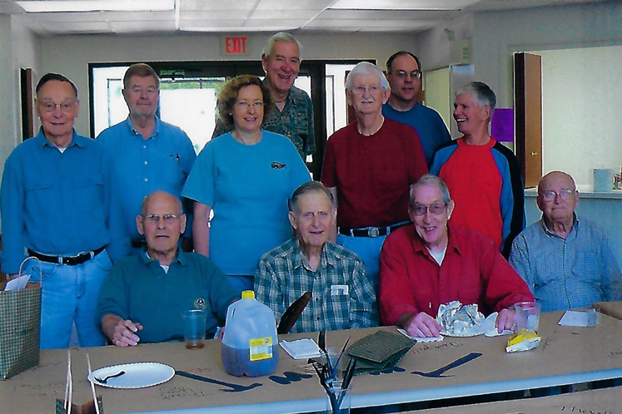

Seated:
Bill Bingaman Frank Nessel
Bob Leach
Art Stettler

Standing:
Rens Swan
Bob Hick
Nancy Hansen Jack Woolfall Bert Hodge
Dave Liscom
Bud Dalrymple
WEDNESDAY WILLING WORKERS
CARILLON DEDICATION
Sunday, September 9th, 11 a.m.

A new computer-driven carillon system was given in loving memory of George B. Beitzel and Mary Bickley Beitzel by Anna (Nancy) Beitzel Hall and George (Spike) Beitzel. Since 1969 the carillon has provided music throughout the community each day. The original carillon was given in memory of Mary Bickley Beitzel and dedicated in worship on October 19, 1969.

CANDLELIGHT CHRISTMAS MUSICAL__
Sunday, December 2nd, 3:30 p.m.

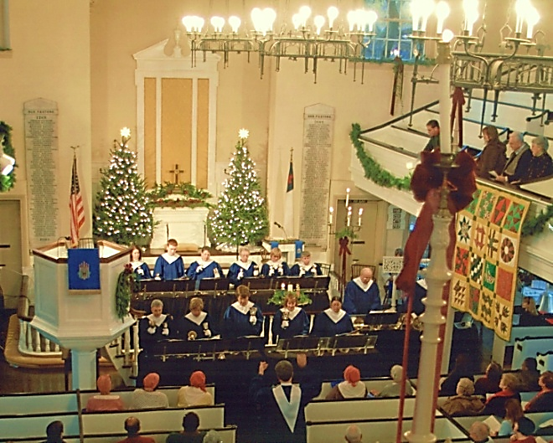
A candlelight Christmas musical was held at historic Old St. George’s United Methodist Church. Covenant’s Ringers were invited to join the North Penn High School Chorus, the Rittenhouse Brass from Curtis Institute, the Select Ensemble from Germantown Academy, and the Children’s Choir from The Church of the Redeemer, Episcopal in Bryn Mawr.

SANCTUARY RENOVATION
The Sanctuary Renovation project’s goal was to maintain the present aesthetic integrity of the Sanctuary, while considering ways to expand the worship space that would allow us to:
● enhance the logistics of the traditional worship service by minimizing the need for frequent furniture and instrument movement
● improve the safety profile of the steps and the chancel area
● facilitate more accessibility for children and youth programming, and
● address the urgent need of replacing the carpet in the Sanctuary

This opportunity was communicated to the congregation through in person presentations and a formal letter. The expected cost of the project was $30,000 funded through congregation one-time memorial gifts. The Board of Trustees indicated a willingness to commit to a portion of the Memorial Fund to meet the financial goal if memorial gifts from the congregation did not fully support the costs. The Sanctuary Renovation Task Force included Don Cadge (Planning and Policy Team), Nancy Hansen (Board of Trustees), Kirk Schneider (Music Program), and Rev. Vandegrift (Pastoral Staff).

The Financial goal was met with gifts totaling over $35,000. More than 110 friends and members participated in this special giving opportunity. A group of artistic and dedicated Covenant women needle-pointed new communion kneeling cushions for the first pew, making use of the design motif and colors that coordinated with the existing altar rail cushions. Competitive bids were reviewed and the decision was to contract the work of the project to Church Interiors, Inc. of High Point, North Carolina. It was anticipated that the construction phase of the project would take place mid-fall.
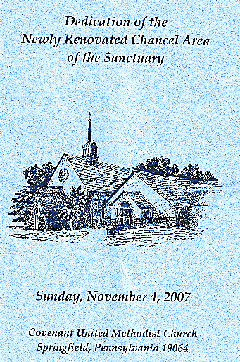
The success of the project of this nature was dependent on the gifts of time and expertise by numerous volunteers:
Bob Hick for daily oversight of the construction project
Bob Leach for electrical expertise
Dave Liscom for ongoing building expertise
Frank Nessel for wood craftsmanship
Wednesday Willing Workers for general assistance
Special thanks were given to Kirk Schneider for his outstanding and thorough leadership and coordination of this project.

In addition, the following women, coordinated by Mavis Berdan and Mary Anne Galloway, donated 3,600 hours in making nine new kneelers:

Nan Armond (Crossed keys) Eleanor Hobdell (Lion & Lamb)
Mavis Berdan (Jonah & the Whale/Scale of Justice) Martha McKibben (Ship)
Mary Anne Galloway (Loaves & Fishes/Bread & Wine) Ruth von Minden (Dove)
Nancy Hall (Candle) Betty Sperow (Needlepoint Design)
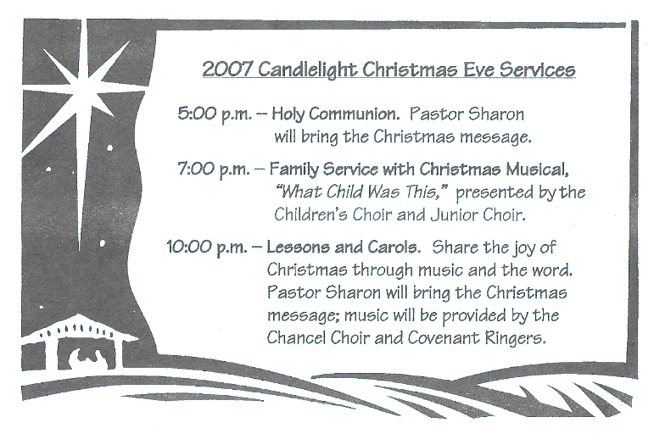
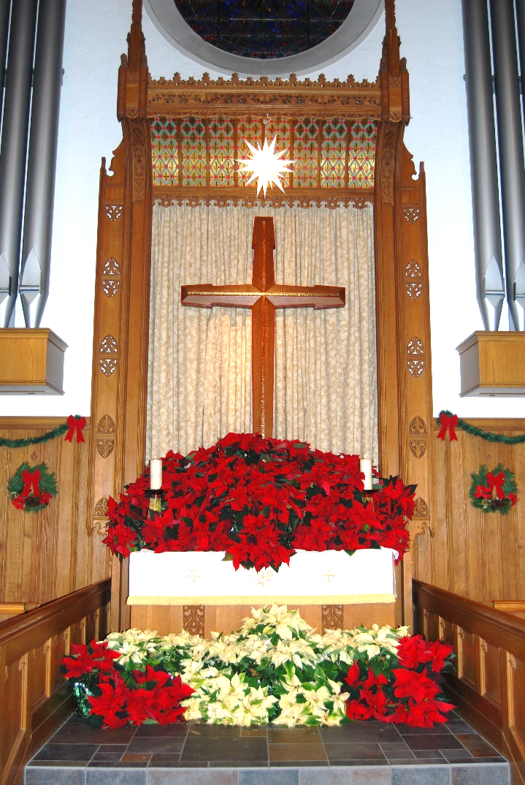
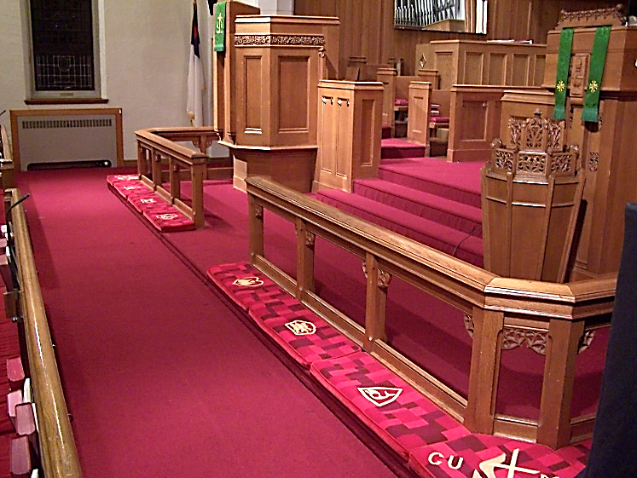
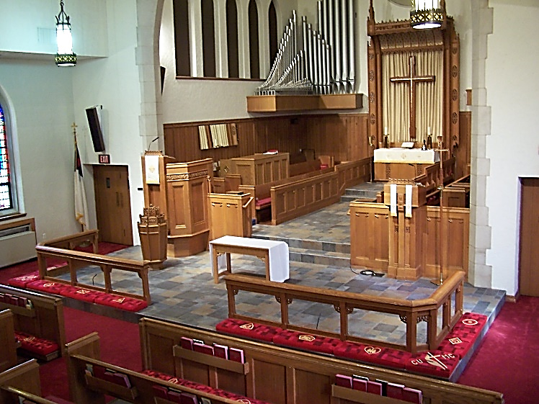
Completed Renovation
Prior to Renovation
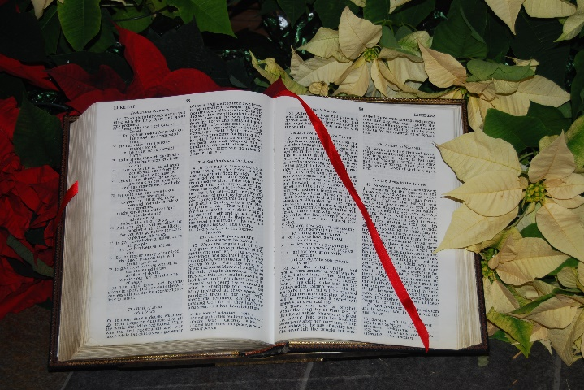
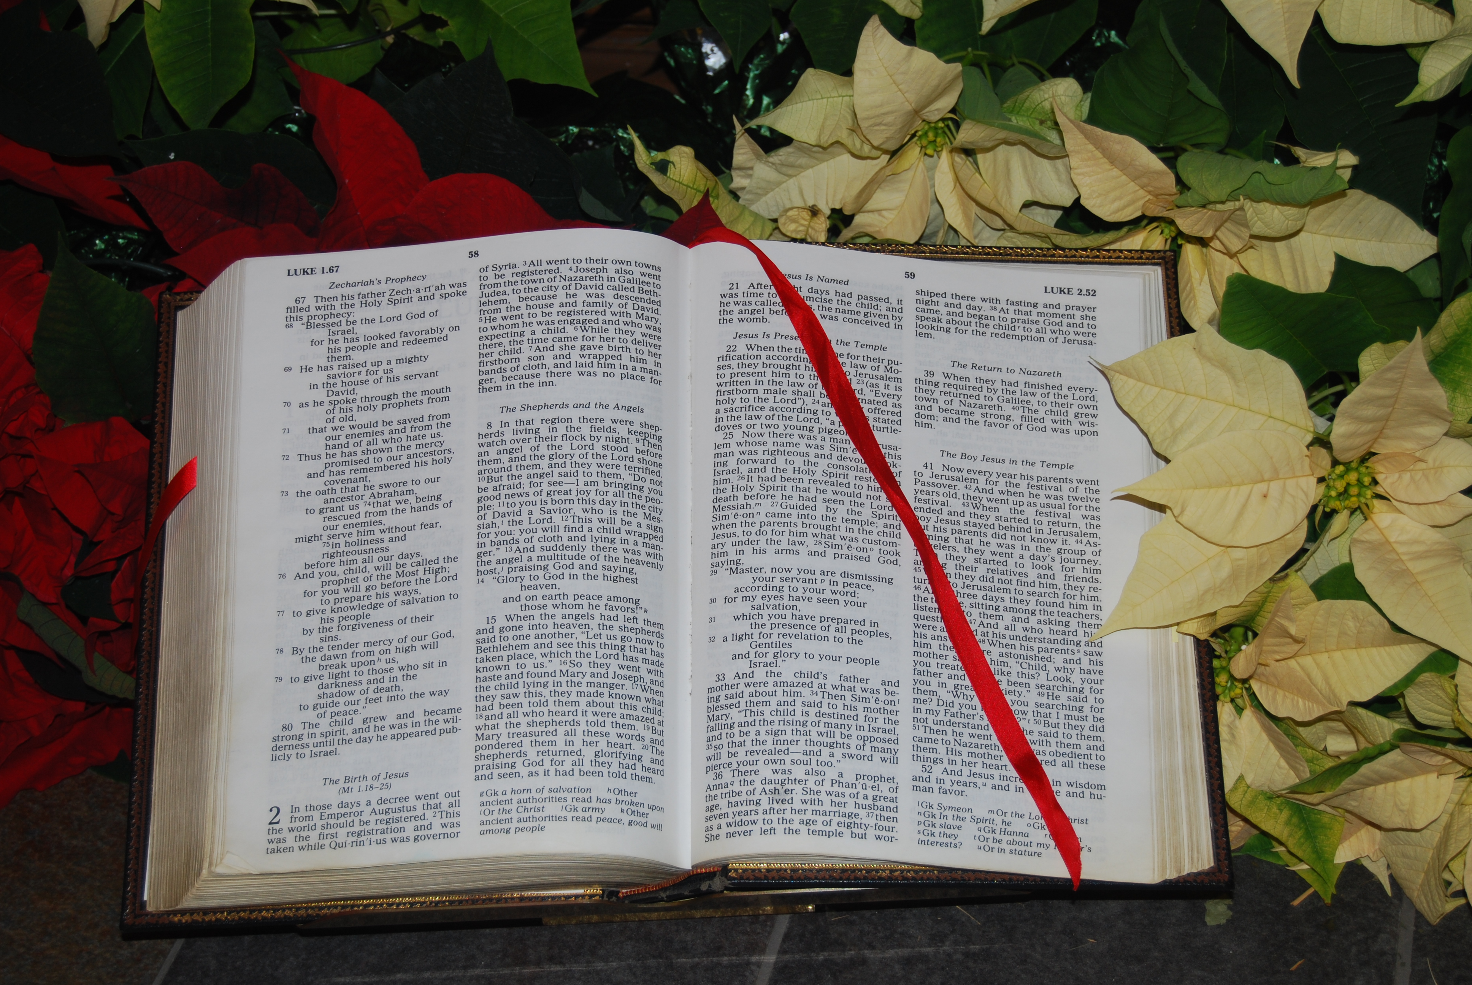
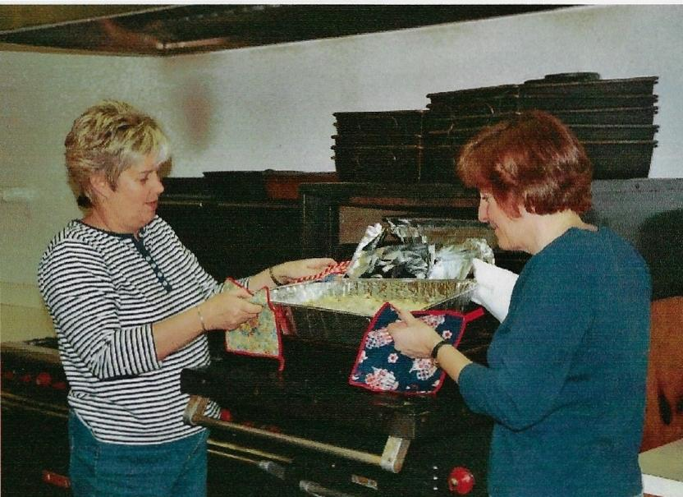
LIFE CENTER DINNER
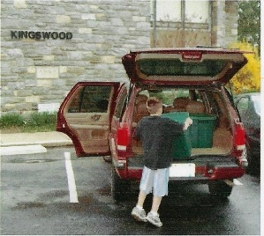

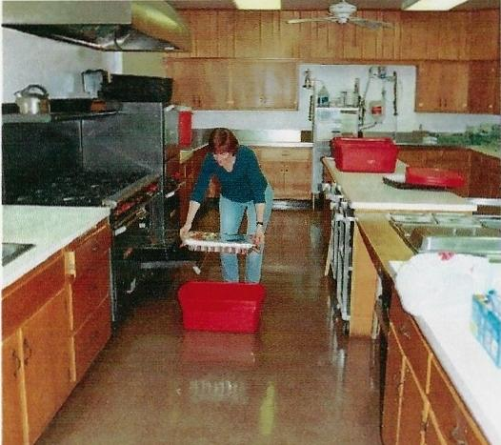
Covenant’s next opportunity to provide dinner for the homeless men, women and children served by the Life Center in Upper Darby occurred on December 14th. Preparing the meal……

2008
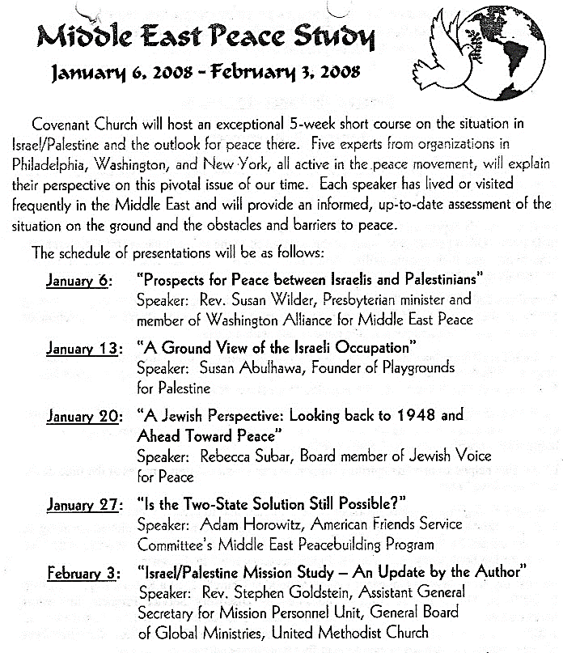
DEDICATION OF SANCTUARY PIANO
Sunday, February 10th, 11 a.m.

The Board of Trustees announced that a gift of a Yamaha Piano for Covenant’s sanctuary was given in memory of Frank Berdan, Jr. by his family. Frank was an organist, avid supporter of Covenant’s music program, and a long-time member of the Chancel Choir. Organ and piano duets performed by Frank and his daughter, Ruth, were frequently heard during summer worship services.

During the dedication service, Sarah Batchelor and Ruth von Minden (Berdan) played several duets on the new piano. The rousing postlude (Ever Joyful by Ralph Manuel) was played by Sarah, Ruth, and Peg Hofberg.

COVENANT MEMBERS IN MISSION

Puerto Rico Mission: On February 1st, Dr. Marie Scott and Laura Scott left Springfield for a Volunteers in Mission trip. They spent a week in the tiny barrio (village) of Mameyes located in the central mountain region of Puerto Rico. Dr. Scott worked in a dental clinic and spent one day traveling to another barrio to see patients. She took as many supplies as she could and set up “shop” in someone’s living room. Laura looked forward to doing electrical work that was needed in the area.

Interfaith Hospitality Network: Covenant partnered with the Episcopal Church of the Redeemer in a program to house and support homeless families from March 2-9. Church of the Redeemer provided the facility, and Covenant worked to offer the volunteer support: everything from making dinner to helping children with homework.
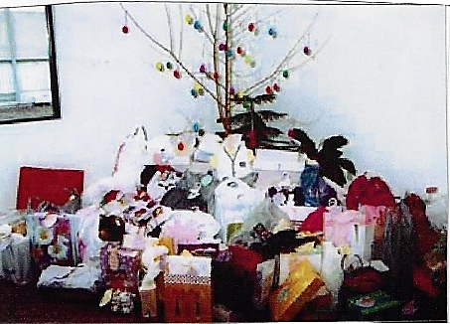
Easter Egg Tree: During Lent, there was an opportunity to select a tag from a tree to purchase a casual dress outfit (or a gift card) for a child or teen housed at the People’s Emergency Center.
Katrina Recovery Mission: In April, Pastor Larry Bergstresser and Dave Liscom led a mission trip to Gulfport, MS to continue to aid local people in the recovery from Hurricane Katrina
Easter Egg Tree
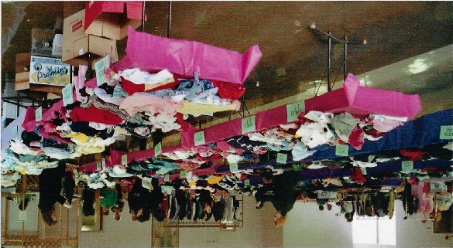
Souper Bowl of Caring: The children of Covenant collected their pennies, nickels, dimes and quarters in Wawa soup cups, and when added all up, they had raised an astonishing $495. This in addition to the congregation’s cash donations of $681 and 322 cans of soup represented 1,498 units besting last year’s total of 1,139. The donations were delivered to Loaves & Fishes pantry in Prospect Park.

YOUTH SUNDAY
March 30th
The Junior and Senior High youth and “RISEN” led worship at both services. “RISEN” (Paul Graham, Gil Groff, Amy Moore, Holly Moore, Nick Pacitti, Laura Scott) opened the service with three pieces and performed the anthem, offertory and postlude. Kathryn Dinkelacker wrote the opening prayer, Chris Roberts and Hayden Karlheim led the Children’s Moment. Hannah and Thomas Hanrahan each read scripture, Lexie Corner prayed the Prayer of Dedication, and Lori Corner gave the Benediction. Also instrumental in planning the service were Chrissy Bannon, Bridgette Campbell, Judson Horna, and Andrea Ridgley.
UMW OUTGROWN SALE, March 29: children's clothing, toys and furniture

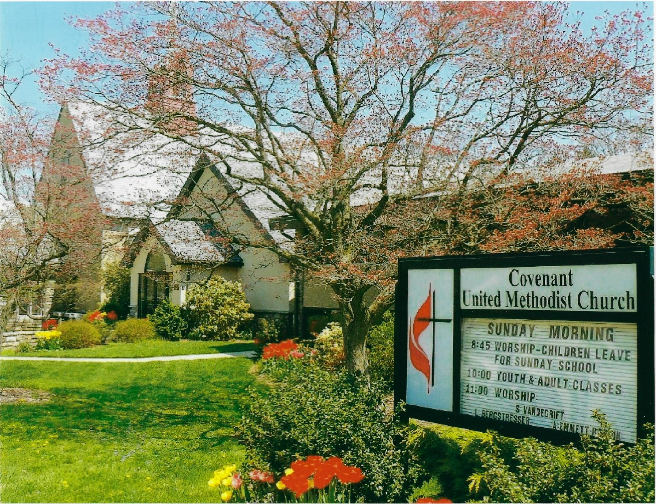
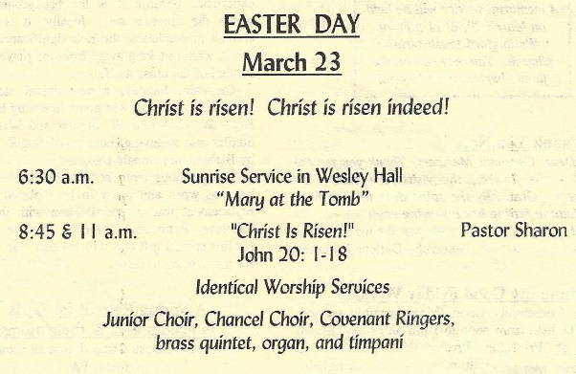
CHOIR FESTIVAL
On Saturday, April 12th, the Junior Choir participated in a Choir Festival with guest conductor Mark Patterson at Central Schwenkfelder Church in Worcester, PA. Mr. Patterson is a well-known composer, music educator and choral clinician and has composed over 200 anthems, many of which Covenant’s choirs have sung and enjoyed. Approximately 115 children from 15 churches participated.
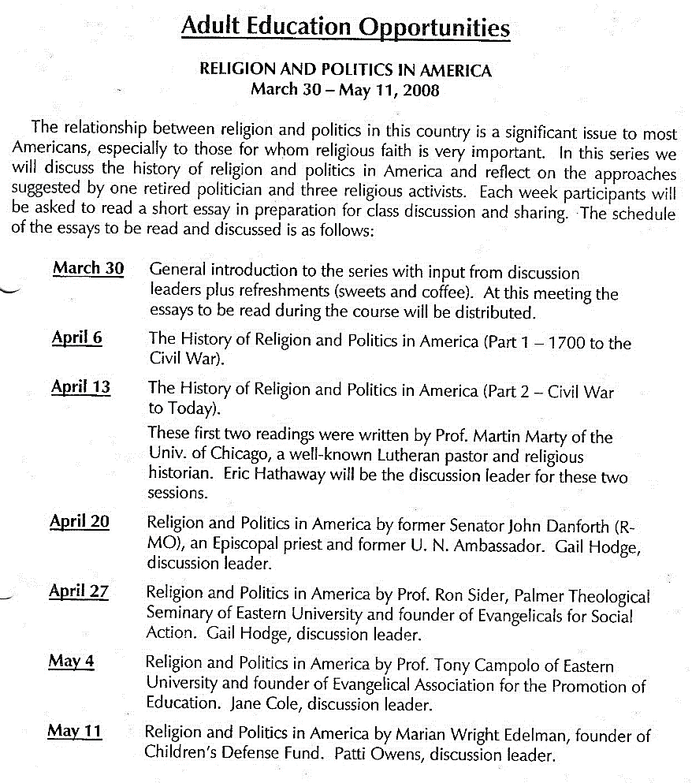
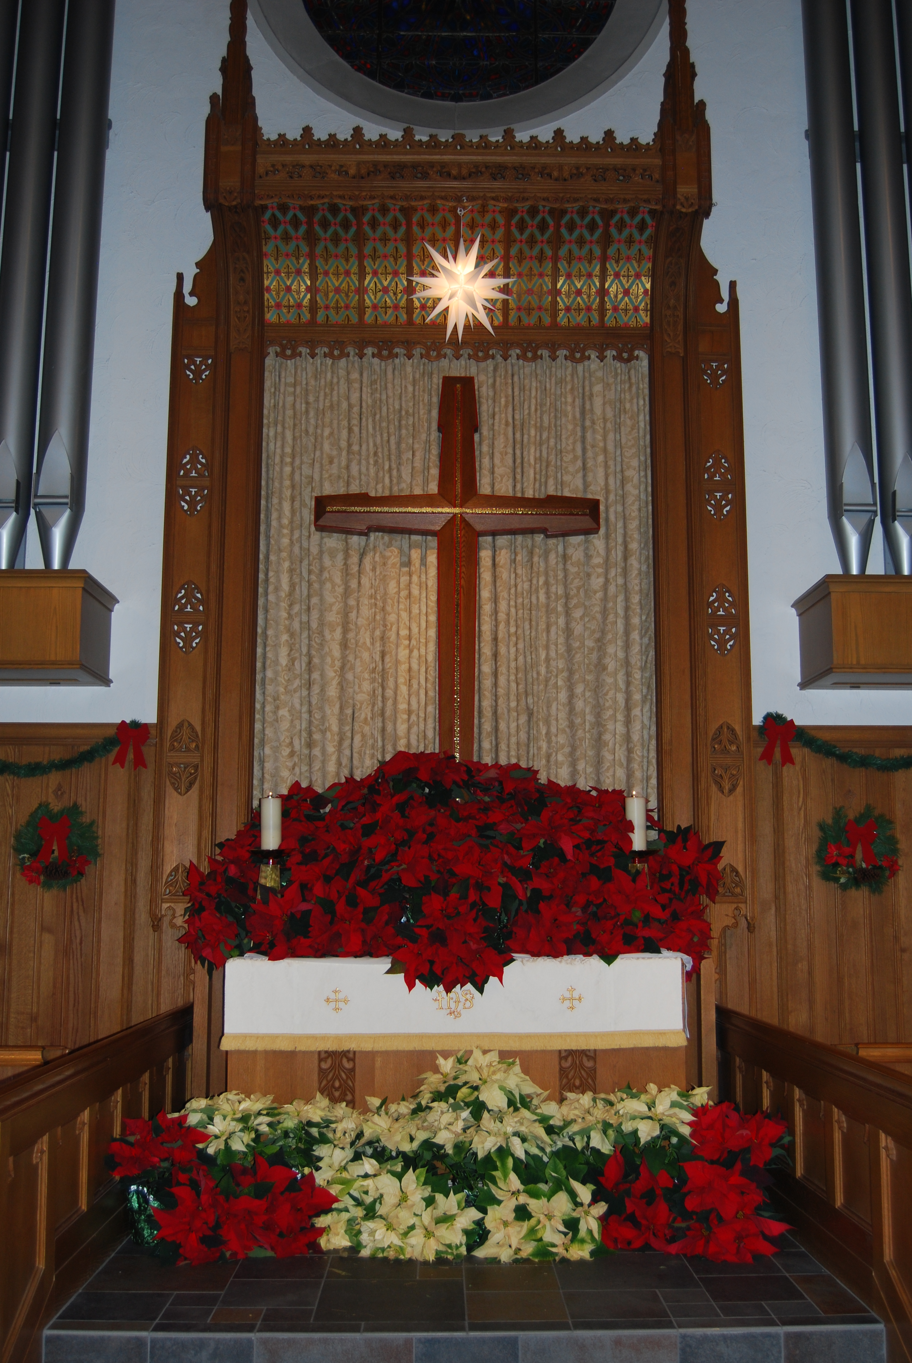
DOSSAL CLOTH DEDICATED

Sitting in the congregation and looking forward, the communion table, the carved wood altar, the silk paraments and the rose window, all work together to draw attention to the cross. The dossal cloth hangs directly behind the cross. On Palm Sunday a new Dossal Cloth was dedicated. This gift was given in loving honor of Doris W. and Arthur W. Stettler and Rev. Wallace F. Stettler and in memory of Sue B. Stettler by
Barbara and Donald Cadge.

CELEBRATING 100 YEARS OF MEN’S MINISTRY

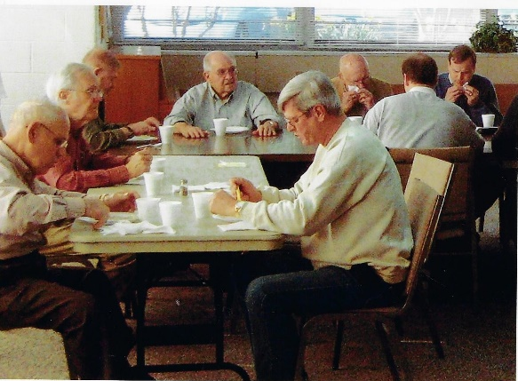
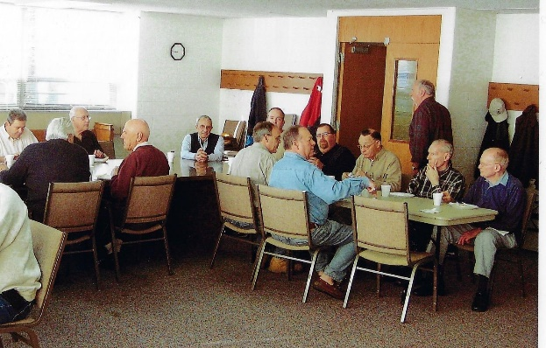
2008 marked the 100th Anniversary of Men Ministry which has been part of all of the predecessor denominations of the United Methodist Church. In 1908, at the General Conference of the Methodist Episcopal Church in Baltimore, the Methodist Brotherhood was approved, making men’s ministry an official part of the denomination.

18 SOUTH HILLCREST ROAD PARSONAGE RENOVATION
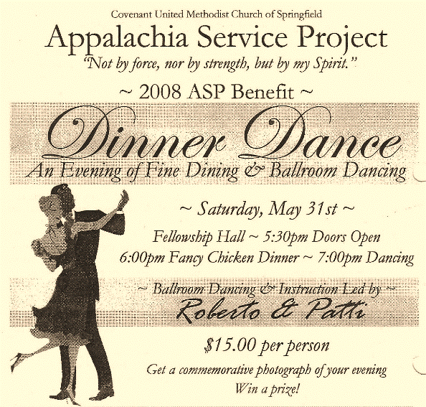
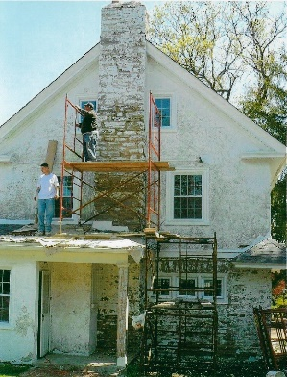
Over the years, Covenant’s parsonage had deteriorated to an extent that it no longer could be considered for use as a parsonage. The Board of Trustees received permission from the District Superintendent to proceed with renovation of the property using monies from the sale of the Williamson Lane parsonage. Over the past year, the repairs proceeded as follows: both the second and third floor bathrooms were refitted with new fixtures, flooring and cabinetry, the roof was completely replaced and all exterior wood surfaces were covered with aluminum. New cabinetry, flooring, lighting and appliances were installed in the kitchen and new drywall was installed in the third-floor bedroom as well as the ceilings in the living and dining rooms. As part of an Eagle Scout project, the brick sidewalk from the street to the back door was reset and grouted, and all the overgrown shrubs in the front yard were removed.
SUNDAY SCHOOL CELEBRATION
On May 25th, more than 30 Sunday School Students and teachers gathered for an end of year celebration. They held an indoor “beach party” dressing up in beach attire, did the limbo, and had a beach ball over-under relay race after which everyone ate water ice. But first, they gathered the money they’ve been collecting for Heifer International and selected an animal to give to a family in need. Everyone was allowed to vote and the clear winner emerged – a LLAMA.

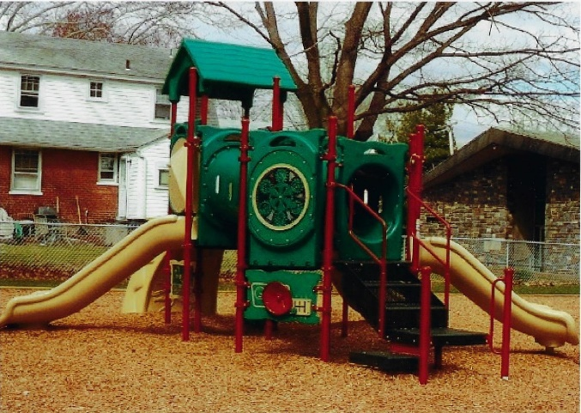
PLAYGROUND PROJECT
Patti Owens, Director of Preschool Ministries, announced that the playground area was in the process of being renovated. A large tree and old garage were removed, a new shed near the side parking lot was erected, and a new play structure was purchased and installed professionally, meeting all State Safety requirements.
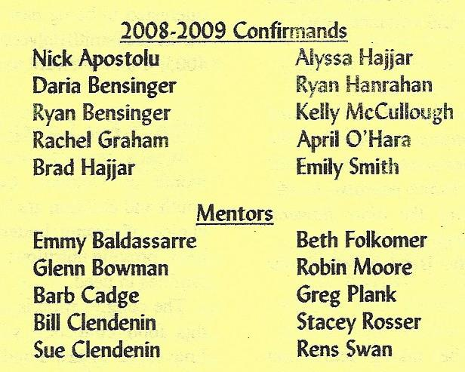
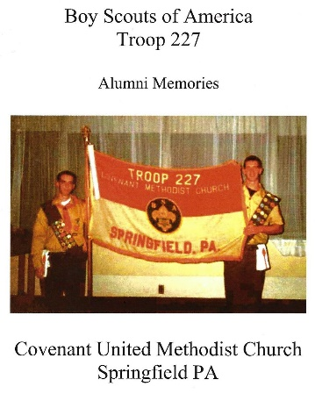
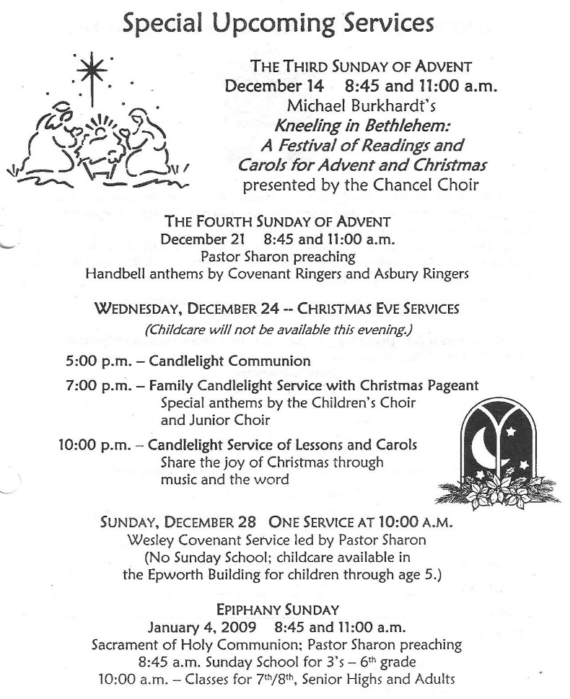
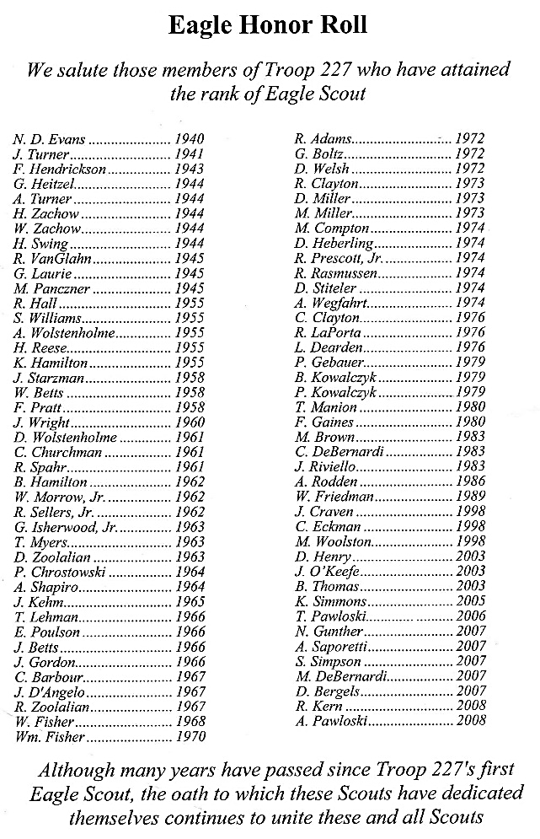
TROOP 227 honored their last two Eagle Scouts and the troop formally disbanded. Troop 227 was chartered in 1937, sponsored by Covenant United Methodist Church. Over the years the troop had been very active in projects serving the community, school and church. 81 scouts attained the rank of Eagle Scout.
PRAYER SHAWL MINISTRY
Joanna Circle started a Prayer Shawl Ministry which was based on a well-know program which makes knitted or crocheted shawls and gives them to persons to are ill, need comfort, or prayer support. Each maker begins the project with prayer, prays as they are working on the shawl, and prays again upon completion. The shawls are consecrated by the pastor before they are passed along to a recipient.

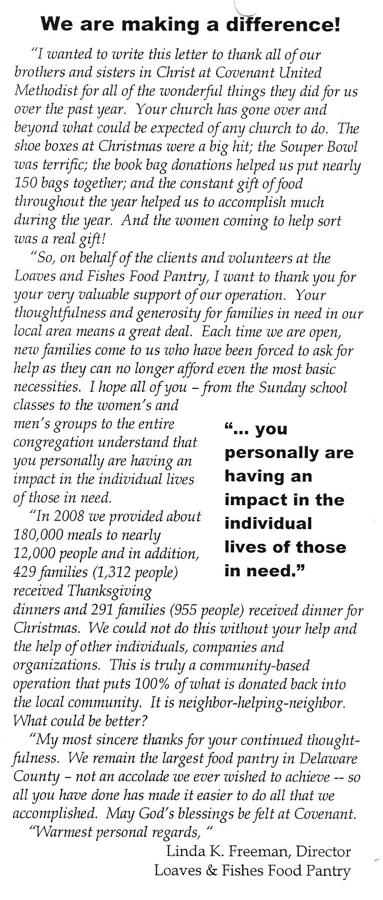
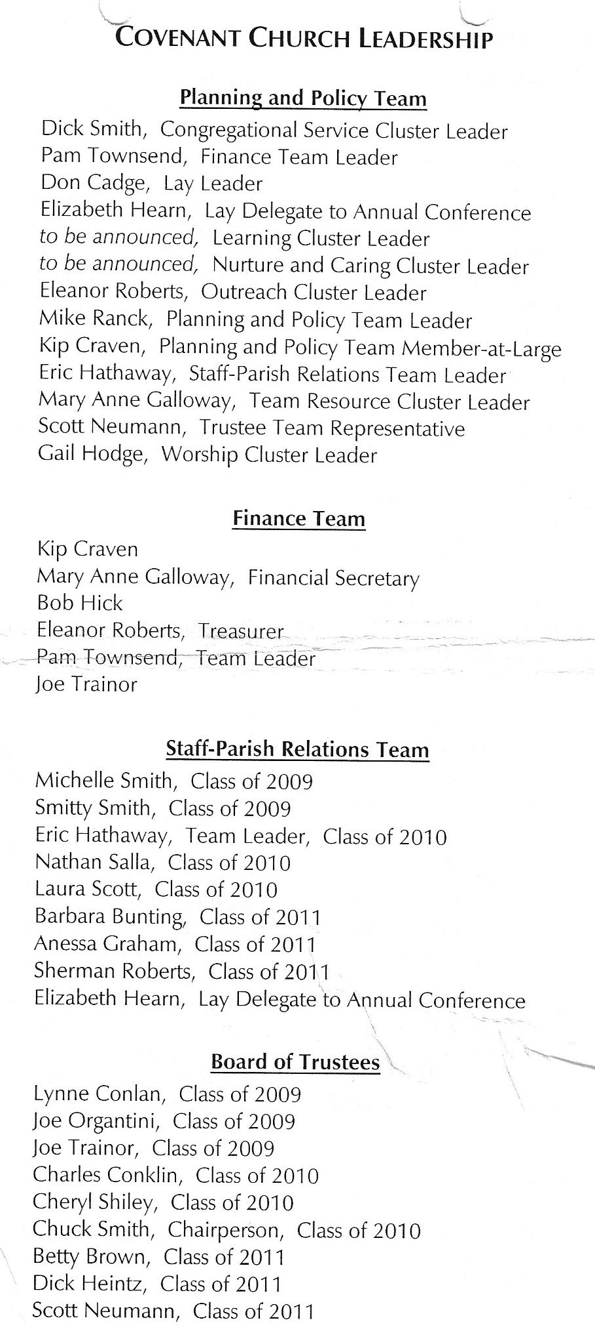
2009
GIFTS FROM THE HEART
The 2008 Gifts from the Heart project was a great success. 65 cards were distributed and a total of $3,520 was donated to the following mission ministries: Appalachia Service Project, Interfaith Hospitality Network, Life Center of Eastern Delaware County, Nutrition Promotion Consultancy Service, and Nothing But Nets.
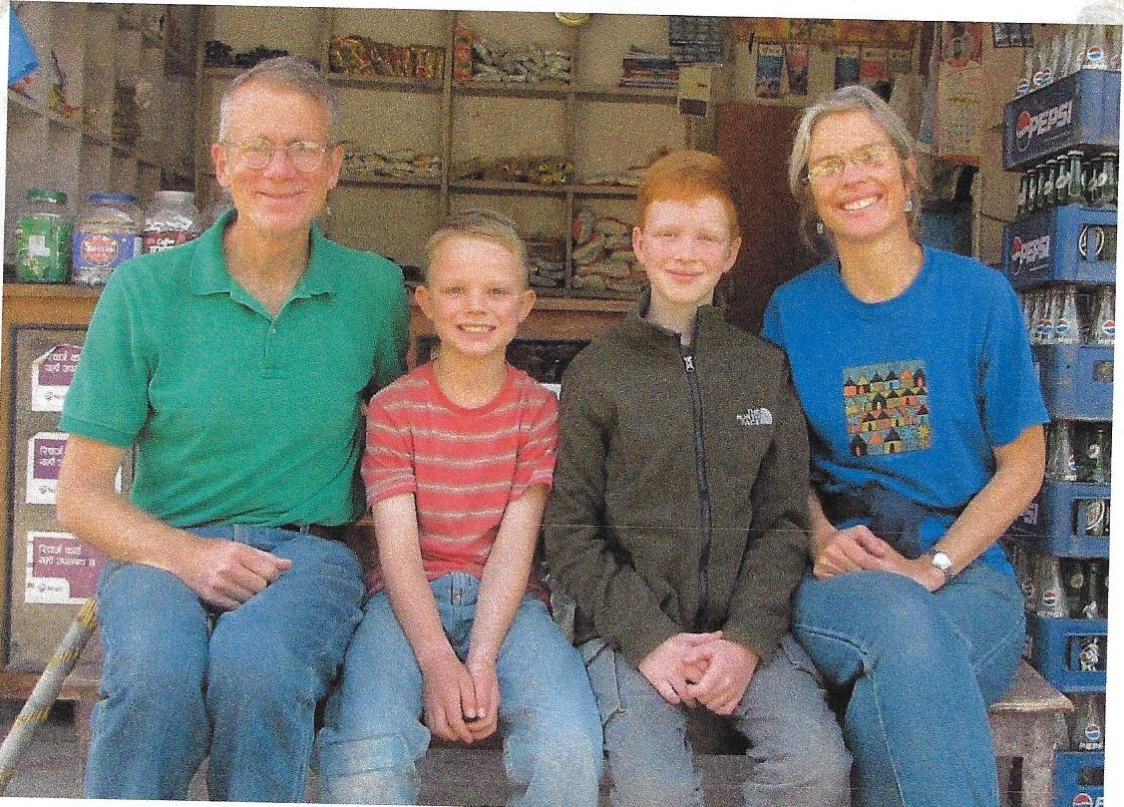
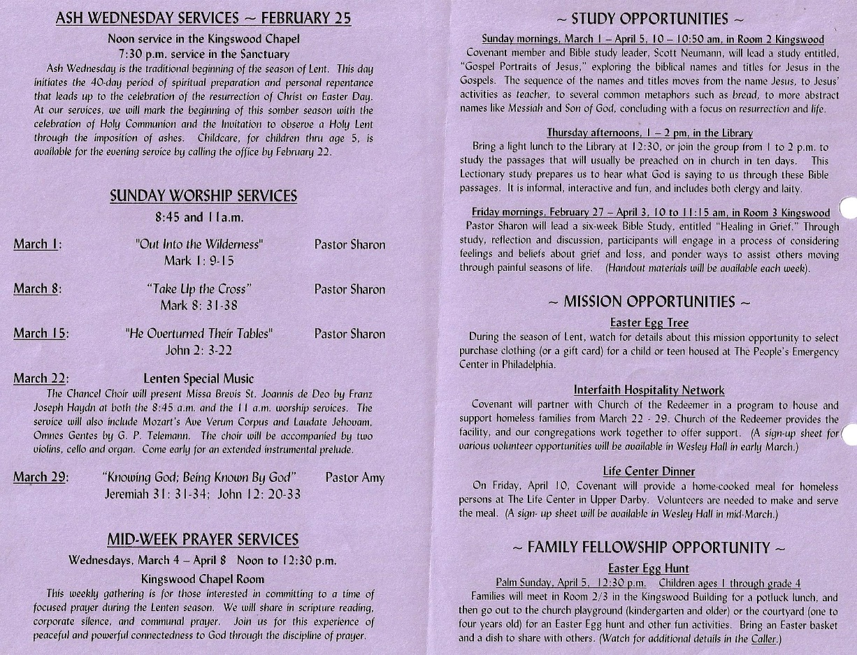
SOUPER BOWL OF CARING SCORES BIG WIN
2009 donations represented all-time record highs: 1,241 cans of food and $1,261 were raised by the efforts at Covenant Church. They have been delivered to The Loaves & Fishes Food Pantry in Prospect Park, PA
MISSION BREAKFAST WITH THE ZIMMERMAN FAMILY
For many years Covenant has supported the work of Dr. Mark Zimmerman, missionary to Kathmandu, Nepal. Mark, his wife Deirdre and their sons, Zachary and Benjamin arrived from Nepal to begin a furlough in the United States. Mark has worked in Nepal as a doctor of internal medicine and also served as medical director of Patan Hospital for a time. He most recently served as Director of the Nick Simons Institute (NSI) where he worked to develop and train doctors and medical personnel throughout all of Nepal. He recently left NSI and returned to Patan Hospital to practice medicine once again. The Zimmerman family were welcomed to Springfield with a special Mission Breakfast on Saturday, March 14th.
100 BAGS OF GROCERIES
Covenant coordinated a collection of lunch foods for needy families who reside in the Springfield/Morton School District. The hope was that families who depended on the school’s free lunch program would find this food especially helpful during spring vacation when school is not in session. The school district assisted in this effort by sending a letter to the appropriate households. 100 bags of groceries were distributed from Covenant’s parking lot on the afternoon of April 5th.
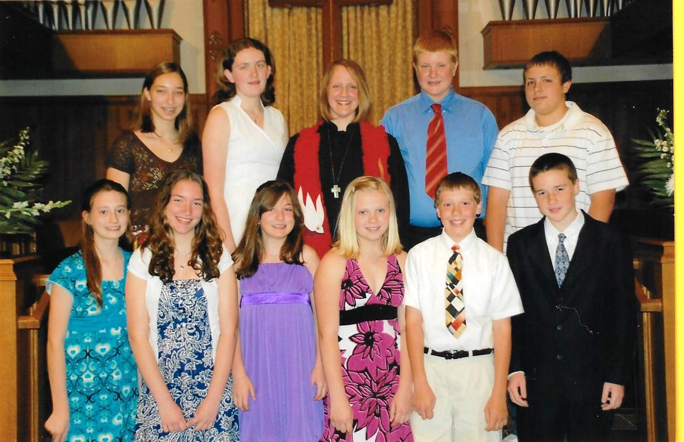
2009 CONFIRMANDS
Confirmands: Nick Apostolu, Daria Bensinger, Ryan Bensinger, Rachel Graham, Alyssa Hajjar, Brad Hajjar, April O’Hara, Ryan Hanrahan, Kelly McCullough, Emily Smith
Mentors: Emmy Baldassarre, Barb Cadge, Glenn Bowman, Bill Clendenin, Sue Clendenin, Beth Folkomer, Robin Moore, Greg Plank, Stacey Rosser, Rens Swan.
PASTOR LARRY CELEBRATES 50 YEARS OF MINISTRY
On Sunday June 28, Covenant had the opportunity to acknowledge Pastor Larry Bergstresser’s 50th year in ministry. Pastor Larry began serving pastoral appointments while he was still a college student. Throughout the next 50 years, he served churches in most of the regions of our Annual Conference. He retired in 2000, then came to Covenant as Pastor of Visitation.

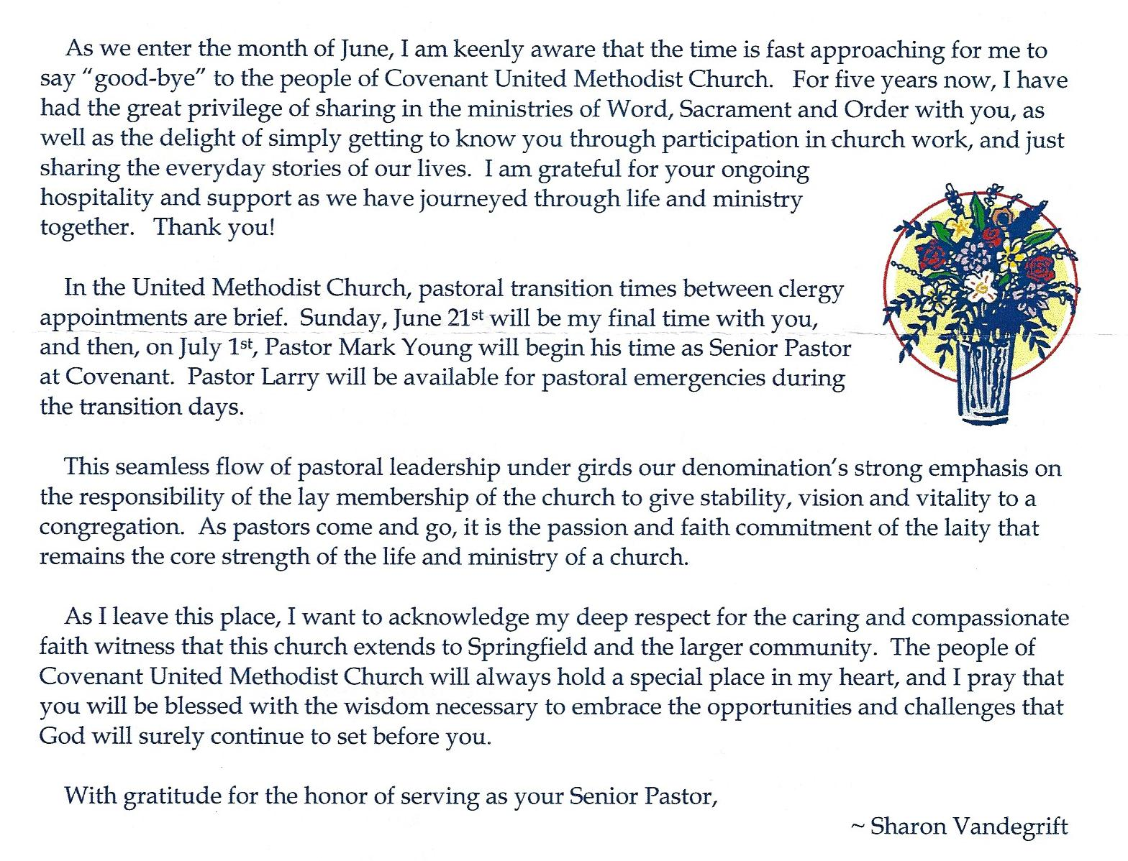
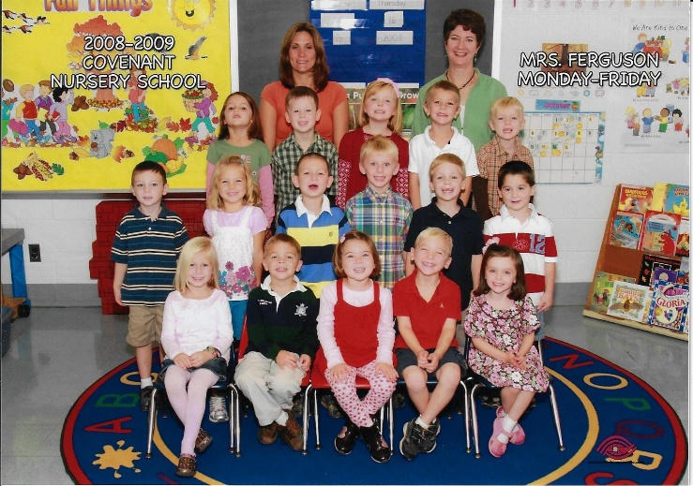
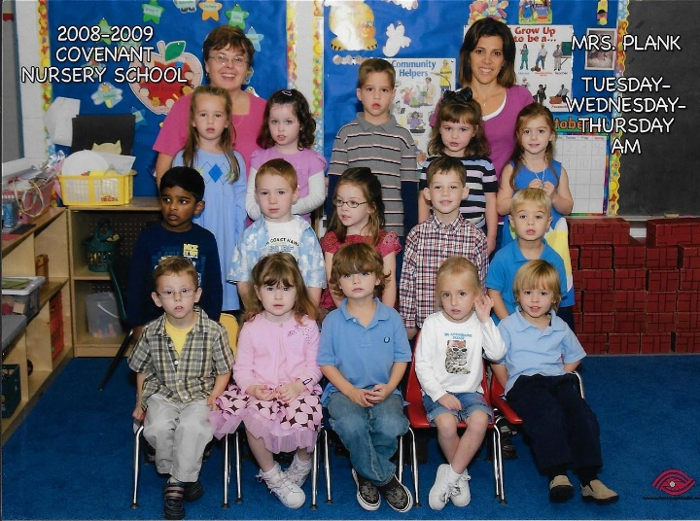
2008-09 Nursery School; Mrs. Ferguson's Class
2008-09 Nursery School; Mrs. Plank's Class
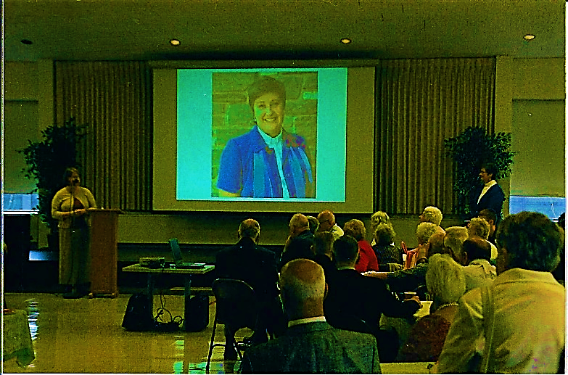
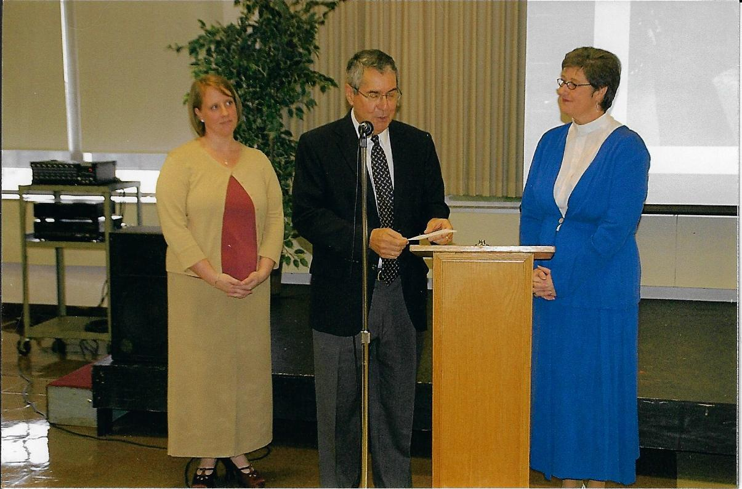
A reception for Pastor Sharon was held on Sunday, June 21st following the 9:30 a.m. service.
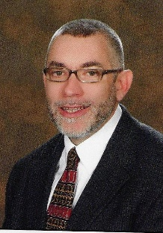
The Staff Parish Relations Team announced that Pastor Mark Young (2009-2012) would become Covenant’s new Senior Pastor effective July 1st. He grew up in the local community and graduated from Springfield High School. From there he attended Boston University and earned his Master’s Degree at Duke University Divinity School. He was ordained an elder in the Eastern Pennsylvania Annual conference in 1991.
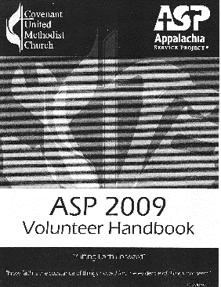
Lee County, Jonesville, Virginia (June 27th – July 5th)
COVENANT 2009 ASP PARTICIPANTS
Chris Apostolu | Marcia Hickey | Dave McCullough
Dan Apostolu | Judson Horna | Stephanie Miller
Dennis Bailey | Hannah Karlheim | Andrea Ridgley
Laura Cadge | Hayden Karlheim | Caitlyn Ridgley
Alexis Corner | Michael Karlheim | Mike Trainer
Greg Corner | David Liscom | Dan Wallin
Lori Corner | Dawn Liscom | Peter Weiss
Jacqui Hickey | Dan Maher
HARVEST HOME
On Sunday, November 22nd, cans of meat, stew, chili, boxes of rice, potatoes, pasta, applesauce and other non-perishable food items as well as monetary donations were received and dedicated. 500 cans of food and $379 were delivered to the Loaves and Fishes Food Pantry.
CHRISMONS FOR UM BUILDING IN WASHINGTON, D.C.
For many years the management company provided a decorated Christmas tree in the lobby of the United Methodist Building in Washington, DC. In spring of 2009, the General Board of Church & Society asked local churches to donate Chrismons for the next Advent season. Because Covenant’s Joanna Circle worked together several years ago to create Chrismons for the Wesley Hall Tree, the Circle happily agreed to participate in this project and worked through the summer months to craft eight new Chrismons for the tree in the lobby of the U.M. Church building in Washington, DC.
LAS POSADAS CELEBRATION
Las Posadas is the Mexican celebration of Mary and Joseph’s journey to Bethlehem from Nazareth and their search for shelter. The celebration culminates in a procession led by a child dressed as an angel and the other children carrying representations of Mary and Joseph. The procession ends at a designed house where the group divides in two with half of the participants acting as innkeepers and the others as Mary and Joseph looking for shelter. After the procession, the celebration transforms from a purely religious one to more of a party with food and a pinata. Covenant’s Las Posadas Advent Festival was held on Sunday, November 22nd with crafts and a covered dish dinner.
WHITE TAG GIFTS
Once again, the congregation of Covenant was most generous with the toys and gifts received on White Tag Sunday. Even with the snow storm, we heard that the Eliza Shirley Shelter and St. Philip’s children both enjoyed their parties. Additional toys were delivered to the Life Center.
KEENAGER’S (a community fellowship group for ages 55+) celebrated their 40th Year with a dinner in Fellowship Hall with entertainment by the Springfield High School Chorus.
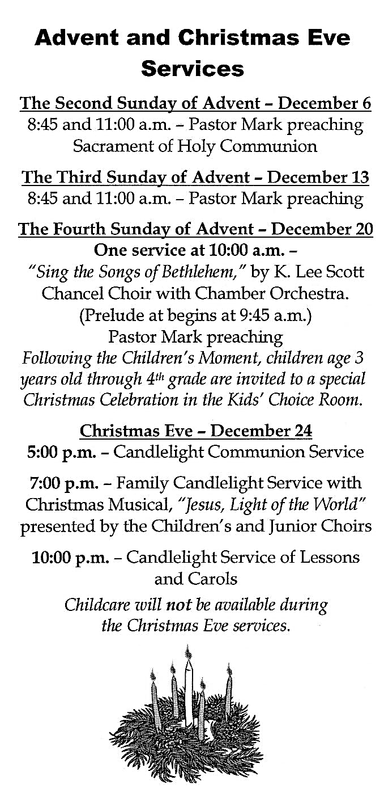
2010
GIFTS FROM THE HEART
The proceeds from the 2009 Gifts from the Heart project resulted in donations totaling $2,210 being distributed to the following mission ministries: Appalachia Service Project, Interfaith Hospitality Network, Life Center of Eastern Delaware County, Nutrition Promotion Consultancy Service, and Loaves & Fishes Pantry.
SOUPER BOWL OF CARING
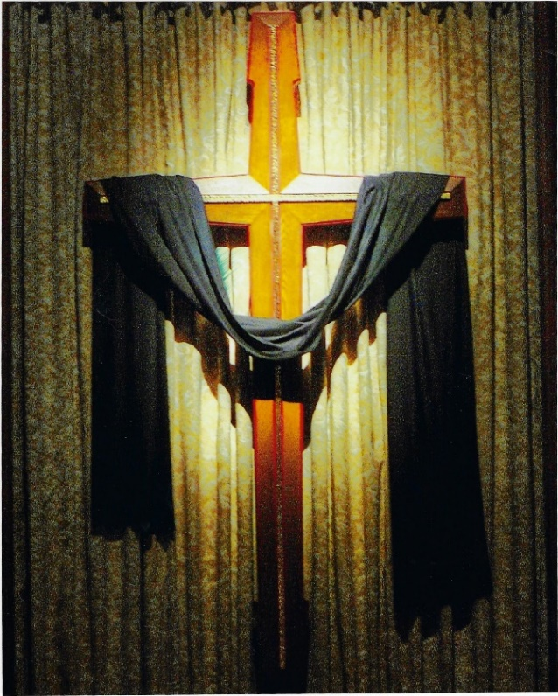
Despite an unprecedented blizzard on Souper Bowl Saturday (2/6) and then a second blizzard three days before the next food collection date (2/13), the community-wide Souper Bowl of Caring ministry collected almost 14,000 cans of food, which was 10% greater than 2009. Sixty-two Covenant members helped out and over 100 Covenant members rented their lawns, putting a sign up. Even more donations came flooding into Covenant Church despite the two blizzards with 1,170 cans of food collected.
PATTI OWENS
Patti Owens informed the Preschool Team that she planned to retire at the end of the school year. Patti was the Director/Teacher of Covenant Nursery School from 1980-1987 then left to do other things. In 2000 she came back to substitute for a maternity leave and was there ever since. The congregation was invited to honor and celebrate Patti’s retirement during the worship service on Sunday, June 6th after which a reception was held in Fellowship Hall.
The COVENANT RINGERS presented a handbell concert at the Keenagers’ meeting on March 9th. Executive Chef, Dawn Liscom, cooked a delicious home cooked meal.

CHANCEL FLOWER MINISTRY
This ministry is composed of three parts: dedication, arrangement, and delivery. The dedication of the flowers by members to honor or remember loved ones was handled by a phone call to Irene Atkinson. John and Linda Lesher began purchasing and arranging the flowers for the altar. The delivery of the flowers to Covenant’s “Homebound” and was overseen by Odette Locher.

IHN WEEK AT COVENANT: Covenant and the Church of the Redeemer offered housing and support to the guests in the Interfaith Hospitality Network (IHN) during the week of May 9th. This was Covenant’s first time to provide the facility with volunteer support coming from both congregations.
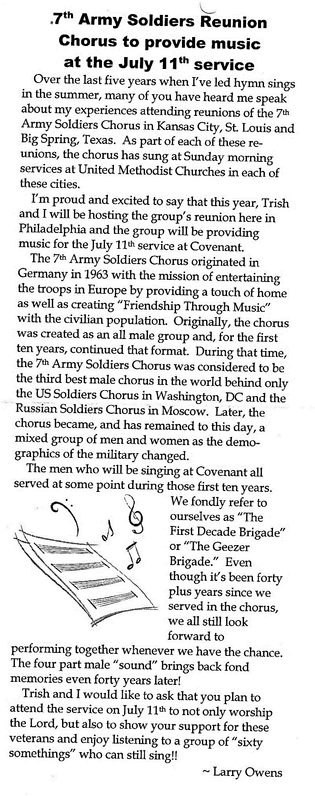
Pastor Amy Emmett-Rardin announced that she decided to leave Covenant at the end of August. In addition to her work at Covenant, she also was a half-time co-director of Asbury Ministry at Drexel University, where she and her husband shared campus ministry together. In addition to the dual appointment, she had her first child. It became apparent to her that this work arrangement was more complicated than anticipated. A farewell reception was held in her honor on Sunday, August 29th.
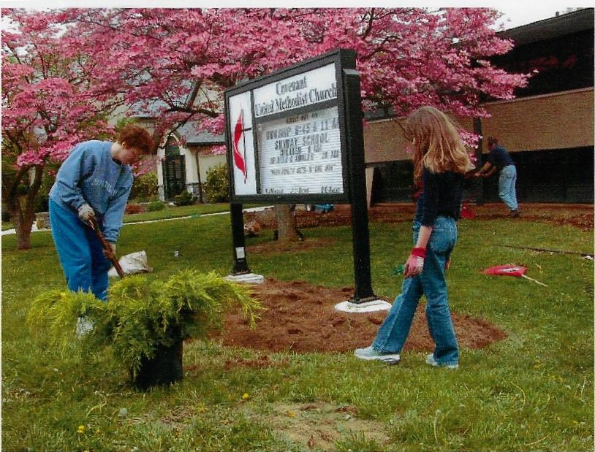
THE GROUND CREWS “TURF”


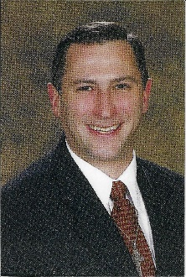
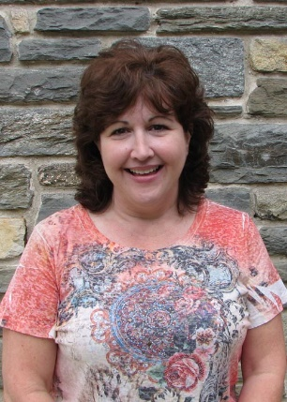
Dawn Hanrahan (2010-present) became Director of Covenant Nursery School in 2010 after over a decade working as one of Covenant’s teachers. She has a solid background in early childhood education and she and her husband also have three children of their own who provide on the job experience in parenting.
Rob Mannix (2010-2016) was welcomed in August as part time Director of Ministries to Children and Families. He was a recent graduate of Lutheran Theological Seminary in Philadelphia. As part of his training, he served in a variety of roles at St. Mark’s Lutheran Church in Clifton Heights.
Dawn Hanrahan
ADULT CHRISTIAN EDUCATION
An 8-week class studied a book about the parables of Jesus as recorded in the New Testament on Sunday mornings in October. The classes were led by Roy Stahlman, Eric Hathaway, and Jim Batchelor.
During November and December, Ken Prager led an adult short course exploring the book “Moral Dilemmas: An Introduction to Christian Ethics.”
Rob Mannix
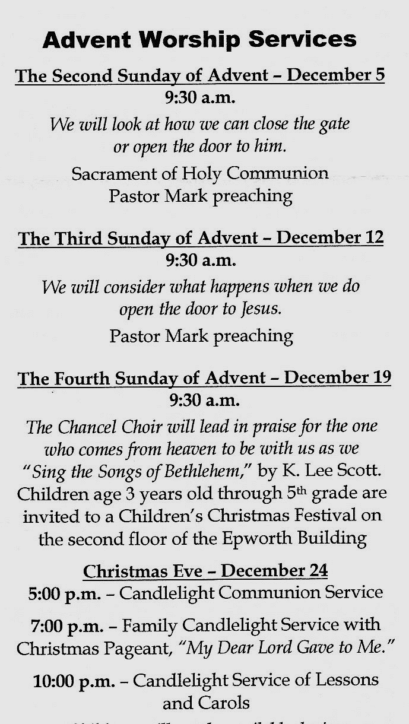
In 2009 Covenant received a very generous gift from a long-time member. The money was set aside until the end of the year to pay off any outstanding bills, then some of it was assigned to purchase new computers for the church offices. The remaining funds were designated for missions. The congregation was asked where this money should be used. The top three suggestions were selected. $5,000 each was given to Loaves & Fishes, Red Bird Mission in Kentucky, and to the work being done in Nepal by Deirdre Zimmerman who worked with a nutrition program for mothers and children.

